Introduction:

Natural disturbances, including fires, windstorms, floods, droughts, and insect outbreaks, have occurred in forests for millions of years (Lindenmayer et al. 2012). In forests of the eastern United States, wind disturbance from hurricanes, derechos (straight-line windstorms), and tornados is a dominant disturbance regime (Fischer et al. 2013). When windstorms knock down canopy trees, the increased sunlight reaching the understory and forest floor can induce environmental changes. Soil temperature extremes can increase, moisture can change depending on reduced evapotranspiration but increased summer temperature, leaf litter depth can decrease due to faster decomposition, and understory plants increase their growth rates (Greenberg and Forrest 2003, Urbanovicova et al. 2014, Barber and Widick 2017). The growth of understory plants interacts with tree mortality and the creation of canopy gaps to alter microclimatic conditions (Perry et al. 2018). The fallen canopy trees cause an influx of woody debris, including both coarse and fine woody debris. Uprooted trees create tip-up mounds that alter topography of the forest floor (Perry and Herms 2019). While wind disturbance changes canopy cover and abiotic conditions, it also leaves behind many living trees, understory shrubs and herbaceous plants, seeds, root systems, soils, and surviving animals. These elements left intact after a disturbance are called biological legacies, and they influence short- and long-term changes in forest structure and function (Lindenmayer et al. 2012).

Harvesting the fallen trees after a natural disturbance is called salvage-logging, and this management practice is a common response to windstorms (Lindenmayer et al. 2012). Salvage logging can help landowners recover the economic value of the fallen trees, or it may be motivated towards reducing fire risk, insect outbreak risk, or safety hazard (Thorn et al. 2014, Perry and Herms 2019). However, there is a growing interest in managing forests in ways that conserve biodiversity, including insect populations that are threatened globally due to environmental change (Wagner 2019). This includes understanding how management practices such as salvage-logging impact insect biodiversity (Thorn et al. 2018). For example, salvage-logging alters the biological legacies left by windstorms by reducing the amount and diversity of woody debris, as well as by disturbance of understory plants, potential for soil compaction from machinery, and modified tree species composition (McNabb et al. 2001, Curtze et al. 2018, Slyder et al. 2020). The combination of natural wind disturbance followed by salvage-logging disturbance could cause longer-lasting changes to the ecosystem.

To understand how insect biodiversity is affected by forest management, an indicator taxon can be used, which is a starting point for characterizing the response of the insect community (Langor and Spence 2006). Ground beetles (Coleoptera: Carabidae) are useful indicators because they are taxonomically well known, sensitive to abiotic and biotic conditions, and sensitive to forest disturbance (Koivula 2011). Ground beetles are diverse in multiple habitats, including both mature forests and early successional habitats such as tallgrass prairies, agricultural fields, urban areas, clearcuts, and floodplains (Silverman et al. 2008, Lambeets et al. 2008, Lundgren and McCravy 2011). Within mature forests, ground beetle communities can differ based on predominate tree species, managed vs. old-growth forest, and forests with dense vs open ground vegetation (Werner and Raffa 2000, Browne et al. 2014, Perry et al. 2018). Thus, the occurrence and species composition of ground beetles can indicate fine-scale differences in habitat.

Two processes occur to the ground beetle community after a forest disturbance: influx of new species and decline of some resident species. After canopy gaps open and early successional plants begin to grow, a guild of open-habitat ground beetles typically disperses to the disturbed area. This group, including certain species of Amara, Anisodactylus, Harpalus, and Chlaenius, may immediately increase following disturbance, or may take a few years to locate the site, depending on landscape structure (Pearce et al. 2003, Sklodowski and Garbalinska 2011, Lee et al. 2017, Barber and Widick 2017). While open-habitat species increase after disturbance, there is also a decline of forest-adapted ground beetles, often over multiple years (Riley and Browne 2011). For example, in Minnesota, jack pine stands that were wind-disturbed or salvaged-logged 1-3 years prior had lower numbers of Pterostichus pensylvanicus LeConte, Pterostichus coracinus (Newman), and Sphaeroderus lecontei Dejean than undisturbed sites (Gandhi et al. 2008). In a pine forest in Poland, forest-specialists decreased in proportional abundance over a six-year period following a tornado (Sklodowski and Garbalinska 2011). These observed decreases in forest-adapted ground beetles after windstorms and salvage-logging could be caused by a variety of factors, including environmental changes such as increased sunlight, increased summer soil temperature, and decreased leaf litter (Greenberg and Forrest 2003). Although many microclimate variables stabilize after multiple years of tree regeneration following a disturbance, other variables, such as woody debris deposition or removal, remain for decades (Gore and Patterson III 1986, Perry and Herms 2019). Studies of clearcuts in Alberta indicate that differences in beetle communities between mature and clearcut forests remain even after 27 years (Pohl et al. 2007). Thus, it is unclear how long it could take for forest-adapted ground beetles to return to areas impacted by windstorms and salvage-logging, and this subject deserves further study to inform salvage-logging practices that may increase with climate change.

While much is known about how the taxonomic composition of ground beetle communities changes after forest disturbance, less is known about how these disturbances may impact the functional diversity of beetles via changes in traits. Studies have documented that ground beetle species common in tornado-disturbed forests were smaller in size, incorporated plant material or seeds into their diets, and were capable of flight, compared to those characteristic of undisturbed forest (Sklodowski and Garbalinska 2011, Perry and Herms 2019). However, ground beetle traits can vary even among, for example, equally-sized, carnivorous, flight-incapable species. For instance, ground beetles exhibit trait syndromes (Fountain-Jones et al. 2015) associated with locomotion strategy (Forsythe 1991), including surface-walking, pushing through leaf litter, burrowing, and climbing plants (Erwin 1979, Larochelle and Larivière 2003). Ground beetle species also differ in their soil moisture preference, and this trait plays an important role in habitat selection (Thiele 1977). Because forest disturbance can affect leaf litter and vegetation cover, soil density, woody debris volume, and soil moisture, these habitat changes could favor species with certain locomotion strategies and moisture preferences. Research is needed to determine if the effect of forest disturbance on ground beetles is mediated by their species-specific traits.

Our objective is to use ground beetles to study the long-term impacts of salvage-logging after a tornado. To do this, we compared the taxonomic and functional diversity of ground beetle communities among undisturbed forest (hereafter “forest”), unsalvaged windthrow (hereafter: “windthrow”), and salvage-logged windthrow (hereafter: “salvaged”) treatments, at three and ten years after a tornado. We predicted that the alpha-diversity (both taxonomic and functional) would be higher for windthrow and salvaged plots than forest control plots after only three years, due to the immigration of open-habitat species and the persistence of some forest species. After ten years, we predicted that salvaged plots would decline in alpha diversity because species that rely on woody debris would not use salvage-logged habitat (Pearce et al. 2003). We predicted that the species and trait composition of windthrow plots would be intermediate between those of salvaged and forest control, due to the intermediate level of disturbance created by windthrow. Finally, we predicted that salvaged plots would support a higher abundance of species with proportionally larger eyes, shorter antennae, and higher water affinity, traits which may increase fitness in a high sunlight, high soil moisture habitat (Bauer and Kredler 1993, McNabb et al. 2001).

Methods

Study site

Research was conducted at Powdermill Nature Preserve (PNR) in Rector, Westmoreland County, Pennsylvania (40° 9' 35.3052'' N, 79° 16' 18.3684'' W). This preserve was established as the field research station for the Carnegie Museum of Natural History in 1956 and is largely temperate deciduous forest. The annual precipitation for the years 2012-2022 was between 45 and 70 in. with a mean of 53 in. (weather station: USC00362183) (“National Centers for Environmental Information: Past Weather” 2012-2022). In June 2012, a tornado uprooted or snapped many canopy trees in two large areas of the forest, each about 120 × 480 m (Figure 1). These two areas are on north- or northwest-facing slopes, which were dominated by maple (Acer spp.), tuliptree (Liriodendron tulipifera), and black cherry (Prunus serotina) (Murphy et al. 2015), with an understory of predominately spicebush (Lindera benzoin) (Calinger et al. 2015). The tornado created patchy areas of canopy openness: the impacted areas had canopy openness values of 25% up to 90% (Slyder et al. 2020). The elevation of the impacted area ranges from around 1650 ft. to 1750 ft. A waterway, Laurel Run, is found along the west side of the impacted areas.

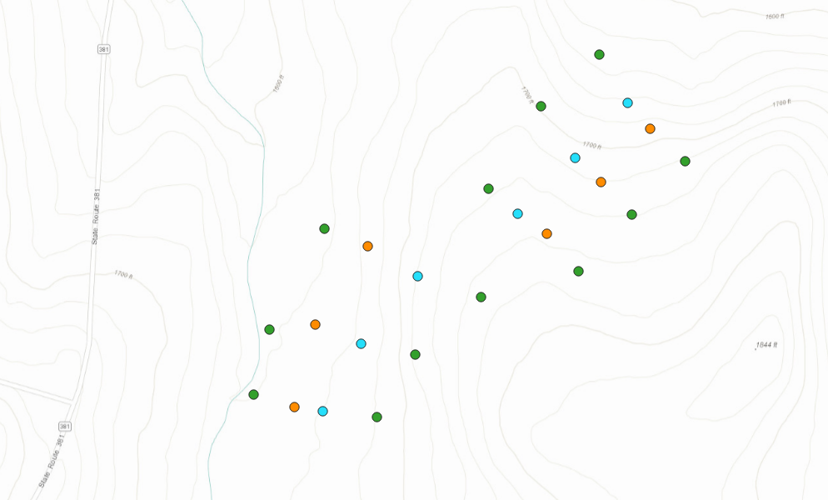
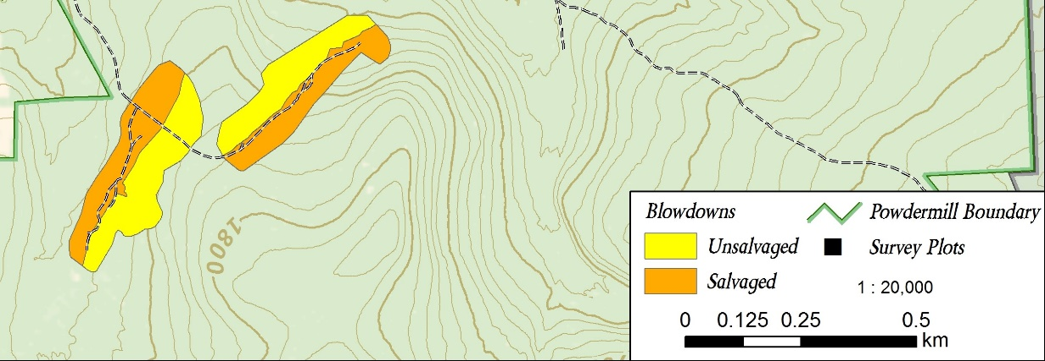
Figure 1. Map of the pitfall trap locations (need to add shapefiles of impacted areas as well as a legend).

From mid-summer through winter of 2013, half of each wind-disturbed area was salvage-logged using heavy machinery to remove both fallen and residual standing trees. In 2015, three transects were established across each area of forest impacted by the tornado (total 6 transects) (Figure 1). Transects were established across the windthrow and salvaged disturbances that extended 50 m into the surrounding undisturbed forest on each side. Along each transect, four plots were established: one plot in windthrow, one in salvaged, and two in the surrounding undisturbed forest. This resulted in a sample size of 24 plots, wherein all data collection occurred.

Ground beetle sampling and identification

Ground beetles were sampled using unbaited barrier pitfall traps in 2015 and 2022, representing three and ten years post-tornado (two and nine years post-salvage-logging). Pitfall traps preferentially collect insects that are more active and mobile, and consequently the number of ground beetles caught in pitfalls is reported as activity-abundance (Gandhi et al. 2008). Barrier pitfall traps consisted of two pairs of plastic cups (each pair having an inner 500 mL cup and an outer 1 L cup) which were placed into the ground so that the lip of the cup was flush with the ground surface. The two pairs of cups were placed 1 m from each other, and garden edging (Suncast® eco edge) was placed between them to create a barrier. Cups were filled 4 cm high with propylene glycol (recreational vehicle and marine antifreeze, Peak Company Old World Industries, Clear Lake, Texas) with a few drops of detergent. Masonite board (100 cm²) was placed at 3 cm above each cup to prevent flooding from rain. Steel hardware cloth was secured over cups using 30 cm stakes to limit mammal disturbance.

Pitfall trap sampling was conducted continuously over the growing seasons in 2015 and 2022. Trap catch was collected every two weeks, and cups were refilled with propylene glycol. In 2015, pitfall traps were installed on 27-28 May, and samples were collected on 9-10 June, 24-25 June, 8 July, 22 July, 5 August, and 17 August. In 2022, traps were installed on 1-2 June, and samples were collected on 15 June, 29 June, 13 July, 27 July, 11 August, and 23 August. Trap catch was collected by pouring the sample through a fine mesh strainer and storing the contents in a specimen cup with 70% ethanol until sorting and identification. In 2022, two additional trapping intervals were collected, on 6 September and 20 September, but these intervals were omitted from analyses so that the years 2015 and 2022 would have equivalent sampling season lengths (see Supplementary Information).

Ground beetles (Carabidae) were identified to species using taxonomic keys (Lindroth 1961, Freitag 1969, Bousquet 2010, Bousquet and Messer 2010, Hunting 2013, Harden and Guarnieri 2017). Nomenclature followed Bousquet (2012). Species vouchers were deposited at the C. A. Triplehorn Insect Collection (OSUC), Museum of Biological Diversity, The Ohio State University, Columbus, Ohio where each specimen was given a unique identifier label (Table S1).

Trait measurements

We selected eight morphological traits of beetles that have previously been shown to relate to habitat (Table 1) (Fountain-Jones, Baker, and Jordan 2015). These traits are body length, antenna length, eye protrusion, eye length, pronotum width, abdomen width, rear leg length, and rear trochanter length. Traits were measured under a dissecting microscope using an ocular micrometer to the nearest 0.1 mm. For each species, traits were measured on up to six individuals, three males and three females (Fountain-Jones, Baker, and Jordan 2015), although we did not achieve this number for rare species. The six individuals were chosen in a way that attempted to encompass the intraspecific variation in body size observed for the species. Most (185/202) specimens used for trait measurement were collected at Powdermill Nature Reserve, but a few (17/202) measured specimens were collected in Erie and Cuyahoga counties, Ohio (Table S1). These specimens were used to supplement the sample size when less than six measurable individuals were collected at Powdermill. To control for variation in beetle body size, relative measurements of all morphological traits were calculated as their ratio to body length for each individual (Ribera et al. 2001). Trait measurements were then averaged across individuals of a species to calculate species-specific means.

In addition to morphological traits, we utilized the reference Larochelle and Larivière (2003) to provide information for three additional traits: flight capability, water affinity, and forest affinity. Flight capability was coded as 1 if the species is flight-capable, 0 if the species is flight-incapable, and 0.5 if the species exhibits wing dimorphism. Water affinity was coded as 0 for xerophilous species, 1 for hygrophilous species, and 0.5 for intermediate species. Water affinity was treated as a physiological trait, because ground beetle species often have consistent humidity preferences in behavioral studies (Thiele 1977). Forest affinity was coded as “forest-specialist,” “open-habitat,” or “eurytopic” (meaning the species is found in forest clearings or in both forest and open habitats). Because only two species we found were recorded as open-habitat species in the literature, we pooled eurytopic and open-habitat species for the statistical analysis.

Table 1. Morphological traits and literature-based traits used in this study, and their connections to habitat variables that could be impacted by forest disturbance.

Trait | Connection to habitat | References
Body length (mm) | Shorter body length was found for ground beetles caught in wind-disturbed forests, relative to undisturbed forests. Body length is correlated with many other morphological traits. | (Barton et al. 2011, Sklodowski and Garbalinska 2011)
Antenna length (mm) | Tactile hunter species, which rely on sense of touch more than vision, tend to have longer antennae. Longer antenna length relative to body length was found for ground beetles caught under a tree, versus in the open. | (Bauer and Kredler 1993, Barton et al. 2011)
Eye protrusion (mm) | A greater eye protrusion was found in a tree-climbing ground beetle, and it may allow partial overlap in the frontal visual field. However, greater eye protrusion might prevent a ground beetle from moving through thick vegetation or soil. | (Talarico et al. 2007)
Eye length (mm) | Diurnal ground beetle species and/or those adapted to open environments tend to rely on vision for predator avoidance or prey detection, and thus might have longer eyes. | (Talarico et al. 2007)
Pronotum width (mm) | A proportionally wider pronotum can be found in robust-bodied beetles, which tend to be found within open habitats. A narrow pronotum can be an adaptation to reaching prey within hard-to-reach soil crevices or snail shells. A narrow pronotum may also be related to the beetle having an unobstructed view behind its eyes. | (Thiele 1977, Forsythe 1991, Barton et al. 2011)
Abdomen width (mm) | Similar pattern to pronotum width, with species having proportionally wider abdomens tending to be found in open habitats. | (Barton et al. 2011)
Rear leg length (mm) | Open habitats seem to favor ground beetle species with shorter legs relative to body length. Ground beetles with longer legs may be weaker at pushing through dense substrates. | (Forsythe 1991, Barton et al. 2011)
Rear trochanter length (mm) | The rear trochanter connects to the femur of the rear leg. Ground beetles have a bean-shaped rear trochanter that allows them to move between narrow crevices between bark, leaf litter, or soil. The muscle in the rear trochanter allows the rear leg to create a force in the dorsal direction, which expands the space and allows the beetle to move through constricted areas. The trochanter is longer, on average, in species that push themselves through soil and underneath leaf litter. It is shorter in species that walk or run above the surface of the substrate. | (Forsythe 1991, Talarico et al. 2007)
Flight capability (range: 0-1) | Flight-capable species (macropterous and with fully developed flight musculature) can exploit patchy, temporary habitats. Conversely, flight incapable species may have higher fitness within stable habitats. | (Ribera et al. 2001, Venn 2016)
Water affinity (range: 0-1) | Habitats vary in the saturation of the substrate with water, and water preference varies between ground beetle species, with some species found near riverbanks or other bodies of water, others found in moist leaf litter, and others found in dry soil. A preference for low humidity may be related to overwintering within tree stumps and logs, versus in the soil. | (Thiele 1977)
Forest affinity (forest specialist, eurytopic, or open-habitat) | Some ground beetle species tend to be caught in forests, underneath trees, whereas other species tend to be caught in fields, prairies, pastures, and other open habitats. | (Silverman et al. 2008)

Forest floor environment

Environmental variables on the forest floor were quantified to assess differences among windthrow, salvaged, and undisturbed forest. Percentage canopy openness was measured using a spherical crown densiometer directly above the pitfall traps to assess light availability on the forest floor. Canopy openness was measured on 9-10 June in 2015, and on 1-2 June in 2022. Percentage cover of ground-level vegetation, leaf litter, bare ground, fine woody debris (<10 cm diameter at the large end), coarse woody debris (≥ 10 cm diameter), and rocks were estimated in two randomly selected 1 m² quadrats around each pitfall trap. Ground cover estimates were collected on 9 June and 7 July and on 1-2 June and 13 July in 2022. Values from the two quadrats around each pitfall trap were averaged together for a site-level mean. Soil moisture was measured at three locations adjacent to each pitfall trap using a Dynamax Inc. (Houston, Texas) TH20 portable soil moisture meter with a Theta Probe ML2x sensor in 2015. Soil moisture measurements were taken biweekly when pitfall samples were collected, for a total of six dates per year. The 18 soil moisture readings at each plot were averaged together for a single mean for the year.

Statistical analysis

To determine if our sampling effort was adequate to characterize the ground beetle community, we used species accumulation curves (SACs) and Chao estimators. For each year and treatment, we created a SAC with number of sampled plots on the x-axis. This was implemented using the specaccum function in the R package ‘vegan’ with the ‘random’ setting, which finds the mean SAC by permuting the order of the plots (Oksanen et al. 2024, R Core Team 2024). The Chao1 estimator was used to estimate a lower bound on the true species richness of ground beetles (Chao and Chiu 2016). This estimator incorporates the number of singletons and doubletons to estimate the number of undetected species and was implemented using the function “ChaoSpecies” in the R package “SpadeR” (Chao et al. 2016).

Before calculating abundance metrics, we accounted for occasional loss of trap catch due to animal disturbance (Perry et al. 2018). Trap catches were standardized based on an 84-day trapping season (6 collection intervals * 14 days per interval). Plots where the trap catch was lost for an interval were corrected by dividing the trap catch by the number of days that the pitfall trap was operational, then multiplying by 84 days. We calculated total activity-abundance of ground beetles as the sum of the activity-abundances of all species at a plot. Furthermore, we decomposed total activity-abundance into two groups: the contribution from forest specialist species, and the contribution from species that are eurytopic or specialize in open-habitats (Larochelle and Larivière 2003). To investigate alpha-diversity at the plot level, we calculated species richness (number of species) and Shannon diversity using the package “HillR” (Li 2018). Shannon diversity was calculated using the formula exp(-Σp_{i}ln(p_{i})), which is the same as the Hill number of order 1. This metric takes values between 1 and the species richness, depending on the degree to which the relative abundances are equal.

We conducted a principal components analysis (PCA) using morphological traits of ground beetles to identify key axes of variation (Swenson 2014). All continuous traits had already been standardized by dividing by body length. We centered each continuous trait to a mean of 0, scaled to a variance of 1, and ran the PCA using the function “prcomp” in the R package “stats” (R Core Team 2024). We removed the species Notiophilus aeneus (Herbst, 1806) from the PCA analysis because inclusion of this rare species, which has unusual morphology, noticeably changed the PC axes (Table S2). After running the PCA, we added Notiophilus back into the analysis by centering and scaling its data using the previously-calculated scaling coefficients and then projecting the values onto the PC axes using the loading values.

We used trait data in combination with ground beetle counts to calculate functional alpha-diversity. We used the first four PC axes, which together explained 89% of the variance in the data, along with the categorical variables Water affinity and Flight capability, to calculate a Gower dissimilarity matrix between all ground beetle species in trait space using the package “FD” (Laliberte et al. 2014). The categorical variables were treated as ordinal data and the “metric” method was used to calculate dissimilarity, so that a wing dimorphic species would be counted as intermediate in its flight capability. After obtaining the dissimilarity matrix, we calculated functional alpha diversity for each plot by computing the intra-plot mean dissimilarity between pairs of species in trait space. Each calculation of dissimilarity between a pair of species was weighted by the product of the species’ relative abundances at the plot, so that more abundant species had a larger influence on functional alpha diversity (Swenson 2014). The calculation was carried out using the function mpd in the R package “picante” (Kembel et al. 2010).

To investigate the average traits of ground beetles at each plot, we calculated community-weighted mean (CWM) trait values. The CWM is the average trait value of all species found at a plot, weighted by the species’ relative abundances. These were calculated for all functional traits, including water affinity and flight capability, using the function “functcomp” in the R package “FD” (Laliberte et al. 2014).

We compared ground beetle communities among forest management treatment and years using linear mixed-effects models with the R package “lme4” (Bates et al. 2015) and “lmerTest” (Kuznetsova et al. 2017). Our response variables were total activity-abundance, activity-abundance of open-habitat and eurytopic species, activity-abundance of forest-specialist species, species richness, Shannon diversity, functional alpha diversity, and community-weighted mean (CWM) traits. In addition to treatment (windthrow, salvaged, undisturbed forest) and year (2015, 2022), we included a treatment*year interaction term in the models. Transect was included as a random effect to account for spatial structure in the data (Figure 1). For some models, the variance of the residuals differed based on the fitted value (heteroscedasticity), so we transformed these response variables using the function f(x)=ln(x) before rerunning the model. In one case, the function g(x)=ln(x+1) was used due to the presence of zeros in the response variable. In some models, a singular fit was obtained, so we removed the random effect term for transect. Because species richness is a count response variable, we used a Poisson generalized linear model (GLM) with the package “stats” (R Core Team 2024). Models were subjected to hypothesis testing using type III sums-of-squares using the package “stats” (R Core Team 2024), or the package “car” (Fox and Weisberg 2019) for the GLM. When the ANOVA showed a significant effect for treatment, pairwise comparisons between treatment groups were made using the package “emmeans” (Lenth 2024).

A similar linear mixed effects model framework was used to assess changes in environmental conditions among forest management treatments over time. Response variables were canopy openness, percentage cover of ground-level vegetation, percentage cover of leaf litter, and soil moisture. Differences in soil moisture among treatments were investigated separately for 2015 and 2022 because a different meter was used for each year.

Measures of beta-diversity were used to investigate changes in taxonomic and functional composition of ground beetle communities among forest management treatments. Taxonomic beta-diversity was calculated using Bray-Curtis dissimilarities between the ground beetle species at each plot using the package “vegan” (Oksanen et al. 2024). The species abundance matrix was first row-standardized to convert the data to relative abundances before the Bray-Curtis dissimilarity between pairs of plots was calculated. We visualized the dissimilarity matrix in two-dimensional space using nonmetric multidimensional scaling (NMDS). Next, we used a permutational multivariate analysis of variance (PERMANOVA) approach to determine if species composition varied by forest management treatment or by year, using 99,999 permutations. Treatment differences were investigated using the pairwiseAdonis package (Martinez Arbizu 2017) and interactions were investigated by running separate PERMANOVAs for each year. Furthermore, we used an analysis of multivariate homogeneity of group dispersions with the “betadisper” function in the “vegan” package to test if the treatments differed in their dispersions. Mirroring taxonomic beta-diversity, we calculated distances between plots using inter-plot mean pairwise distance in trait space with the function “comdist” in the R package “picante” (Kembel et al. 2010). Using the previously calculated Gower dissimilarity matrix, the “comdist” function calculates the expected distance in trait space between an individual beetle drawn randomly from the first plot and an individual beetle drawn randomly from the second plot. The NMDS, PERMANOVA and beta-dispersion analyses were performed in a similar manner.

Results

Across 2015 and 2022 between the months of June and August, a total of 1537 individuals comprising 47 species of ground beetles were collected (Table 2). Of these 47 species, 27 were caught both in 2015 and in 2022, 10 species were caught only in 2015, and 10 species were caught only in 2022. The most abundant species were Pterostichus moestus Say (15.1% of individuals collected), Chlaenius emarginatus Say (10.5%), and Sphaeroderus stenostomus (10.3%). Of the 47 species caught, 2 were classified in Larochelle and Larivière (2003) as open-habitat specialists, 24 were eurytopic (ie. habitat generalist), 20 were forest-specialist, and one species had unknown habitat affinity. The Chao1 estimator for the true number of ground beetle species in 2015 was 47.1 species (95% conf. int. 39.3 - 82.2 species) while in 2022 the Chao1 estimator was 79.2 species (95% conf. int. 46.2 – 230.7 species). Thus, our sampling effort captured approximately 37/47 = 79% of the estimated species present in 2015, and 37/79 = 47% of the estimated species present in 2022. Species accumulation curves for each treatment and year showed that species richness had begun to level out with increasing number of plots (Figure S2).

Species richness and activity-abundance of ground beetles were affected by forest management treatment, and in some cases, year of sampling. Species richness of ground beetles was higher in salvaged plots than forest control plots, while windthrow plots were intermediate (Fig. 2B, Tables 3-4). However, Shannon diversity was similar among treatments and years. Activity-abundance showed a pattern of interaction between treatment and year. In 2015, activity-abundance was higher in salvaged plots relative to windthrow and forest controls, but this pattern disappeared in 2022, as total activity-abundance was similar among treatments (Fig. 2A). When the activity-abundance of open-habitat and generalist species was counted, it was higher in salvaged plots than forest plots (Fig. 3A). Forest specialist activity-abundance was similar among treatments and years. However, there was a non-significant trend of increased forest specialist activity-abundance in salvaged plots in 2015, followed by a decrease in salvaged plots in 2022 (Fig. 3B).

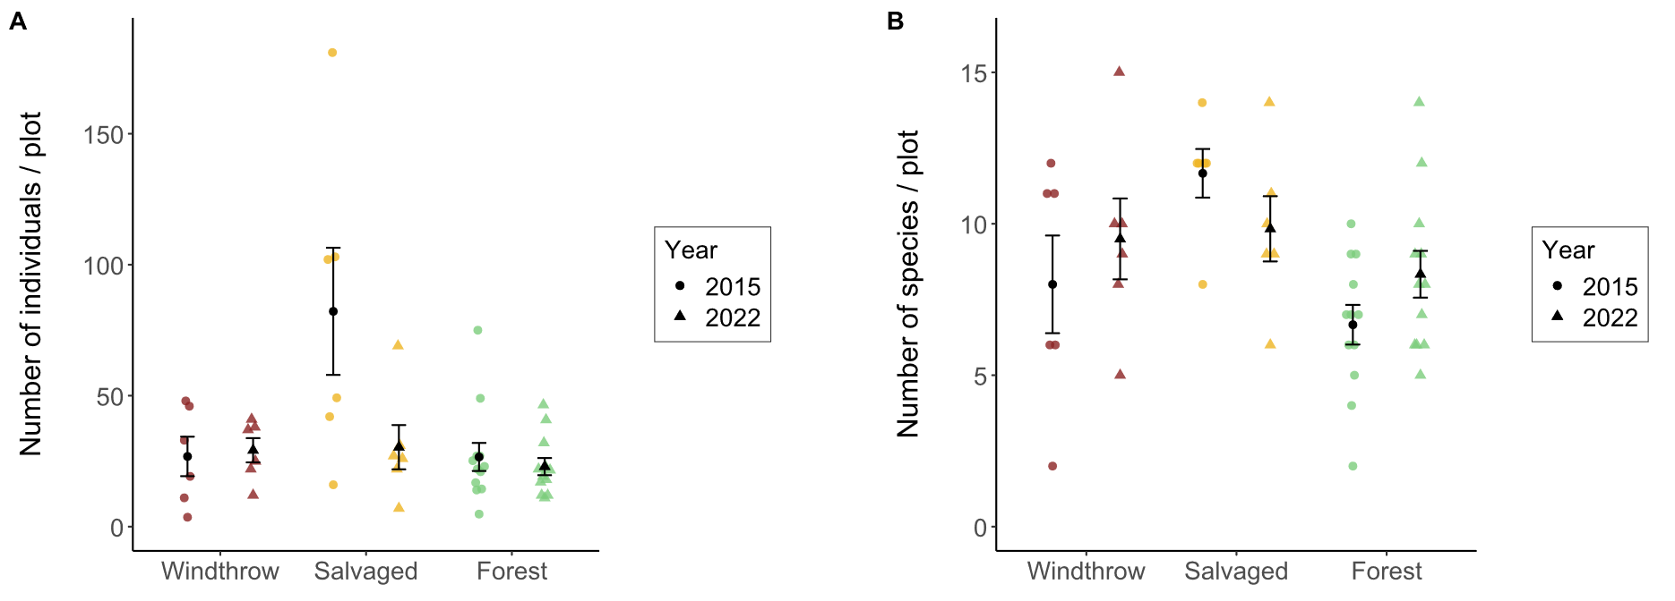Figure 2. Total activity-abundance (A) and species richness (B) of ground beetles collected in windthrow, salvaged, and undisturbed forest in 2015 and 2022 at Powdermill Nature Reserve, Rector, Westmoreland County, Pennsylvania, USA. Bar height is the group mean, and whiskers indicate the standard error of the mean.
.
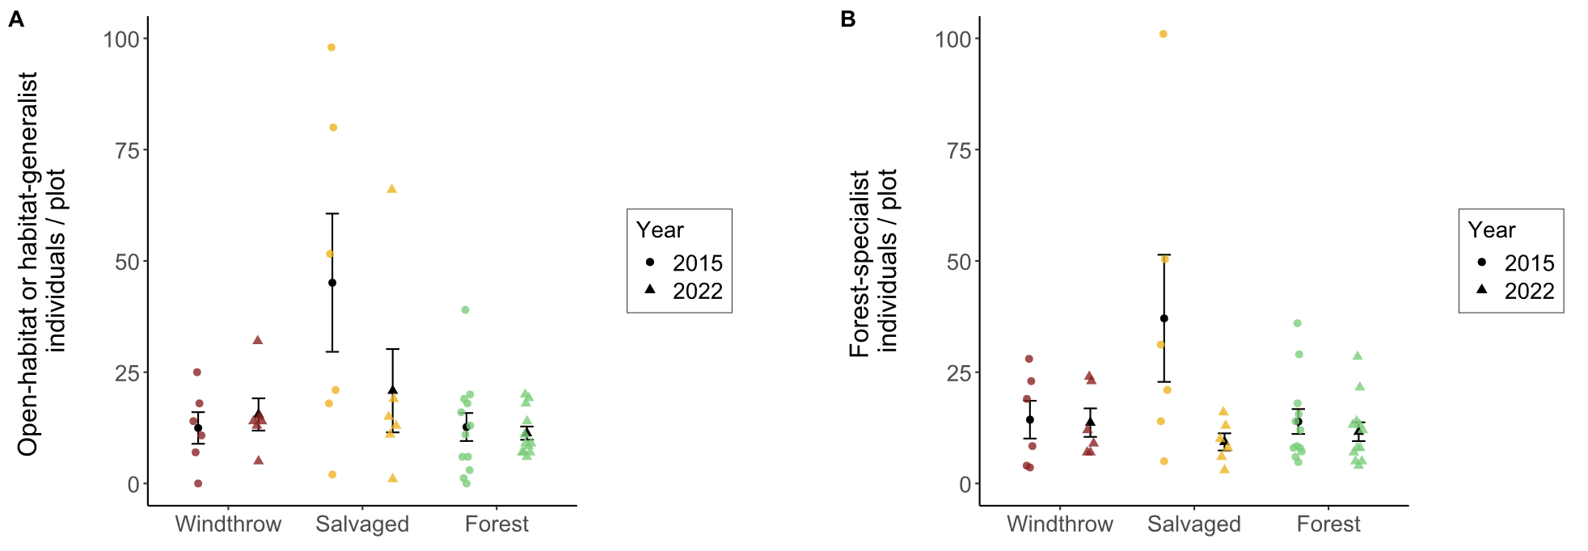
Figure 3. Activity-abundance of open-habitat or habitat-generalist ground beetle species (A) and forest-specialist species (B) collected in windthrow, salvaged, and undisturbed forest in 2015 and 2022 at Powdermill Nature Reserve, Rector, Westmoreland County, Pennsylvania, USA. The forest affinity information was collected from Larochelle and Larivière (2003). Bar height is the group mean, and whiskers indicate the standard error of the mean.

Table 2. Total trap catch of ground beetle species (Coleoptera: Carabidae) collected via pitfall traps at Powdermill Nature Reserve, Rector, Westmoreland County, Pennsylvania, USA. Sampling occurred from 27 May to 17 August, 2015, and from 1 June to 23 August, 2022.

Tribe | Species | Code | 2015 | 2022 | Total
Notiophilini
 | Notiophilus aeneus (Herbst, 1806) | No.ae | 2 | 1 | 3
Cychrini
 | Sphaeroderus canadensis | Sp.ca | 35 | 7 | 42
 | Sphaeroderus stenostomus | Sp.st | 76 | 82 | 158
 | Scaphinotus viduus (Dejean, 1826) | Sc.vi | 1 | 1 | 2
 | Scaphinotus imperfectus (Horn, 1861) | Sc.im | 0 | 3 | 3
Carabini
 | Carabus goryi Dejean, 1831 | Ca.go | 66 | 33 | 99
Pterostichini
 | Lophoglossus scrutator (LeConte, 1846) | Lo.sc | 0 | 1 | 1
 | Pterostichus mutus (Say, 1823) | Pt.mu | 1 | 0 | 1
 | Pterostichus corvinus (Dejean, 1828) | Pt.co | 6 | 0 | 6
 | Pterostichus sayanus Csiki, 1930 | Pt.sa | 0 | 1 | 1
 | Pterostichus coracinus (Newman, 1838) | Pt.co | 28 | 14 | 42
 | Pterostichus melanarius (Illiger, 1798) | Pt.me | 1 | 0 | 1
 | Pterostichus lachrymosus (Newman, 1838) | Pt.la | 27 | 45 | 72
 | Pterostichus stygicus (Say, 1823) | Pt.st | 62 | 70 | 132
 | Pterostichus hamiltoni Horn, 1880 | Pt.ha | 0 | 1 | 1
 | Pterostichus moestus (Say, 1823) | Pt.mo | 185 | 47 | 232
 | Pterostichus diligendus (Chaudoir, 1868) | Pt.di | 1 | 1 | 2
 | Pterostichus rostratus (Newman, 1838) | Pt.ro | 36 | 22 | 58
 | Pterostichus adoxus (Say, 1823) | Pt.ad | 19 | 80 | 99
 | Pterostichus tristis (Dejean, 1828) | Pt.tr | 10 | 31 | 41
 | Cyclotrachelus fucatus (Freitag, 1969) | Cy.fu | 5 | 1 | 6
 | Cyclotrachelus convivus (LeConte, 1853) | Cy.co | 1 | 0 | 1
 | Cyclotrachelus sigillatus (Say, 1823) | Cy.si | 22 | 52 | 74
Chlaeniini
 | Chlaenius emarginatus Say, 1823 | Ch.em | 137 | 25 | 162
 | Chlaenius laticollis Say, 1823 | Ch.la | 2 | 0 | 2
Licinini
 | Dicaelus politus Dejean, 1826 | Di.po | 54 | 13 | 67
 | Dicaelus teter Bonelli, 1813 | Di.te | 68 | 10 | 78
Harpalini
 | Notiobia nitidipennis (LeConte, 1847) | No.ni | 6 | 0 | 6
 | Anisodactylus harrisii LeConte, 1863 | An.ha | 2 | 1 | 3
 | Anisodactylus melanopus (Haldeman, 1843) | An.me | 1 | 0 | 1
 | Anisodactylus nigerrimus (Dejean, 1831) | An.ni | 3 | 5 | 8
 | Amphasia interstitialis (Say, 1823) | Am.in | 6 | 0 | 6
 | Agonoleptus thoracicus (Casey, 1914) | Ag.th | 0 | 1 | 1
 | Harpalus spadiceus Dejean, 1829 | Ha.sp | 1 | 11 | 12
 | Trichotichnus autumnalis (Say, 1823) | Tr.au | 10 | 2 | 12
Sphodrini
 | Pseudamara arenaria (LeConte, 1847) | Ps.ar | 2 | 1 | 3
Platynini
 | Olisthopus parmatus (Say, 1823) | Ol.pa | 3 | 2 | 5
 | Agonum ferreum Haldeman, 1843 | Ag.fe | 1 | 0 | 1
 | Agonum fidele Casey, 1920 | Ag.fi | 31 | 3 | 34
 | Agonum retractum LeConte, 1846 | Ag.re | 1 | 0 | 1
 | Platynus decentis (Say, 1823) | Pl.de | 0 | 1 | 1
 | Platynus tenuicollis (LeConte, 1846) | Pl.te | 3 | 5 | 8
 | Platynus angustatus Dejean, 1828 | Pl.an | 19 | 17 | 36
Lebiini
 | Cymindis limbata Dejean, 1831 | Cy.li | 0 | 1 | 1
 | Cymindis platicollis (Say, 1823) | Cy.pl | 0 | 1 | 1
 | Apenes lucidula (Dejean, 1831) | Ap.lu | 0 | 8 | 8
Galeritini
 | Galerita bicolor (Drury, 1773) | Ga.bi | 0 | 3 | 3
Total |  |  | 934 | 603 | 1537

The principal components analysis (PCA) of the eight numerical traits generated a set of axes, of which the first four axes together explained 89% of the variance (Table S2). The first PC axis (39% of the variance) was associated with proportionally shorter antennae, shorter rear legs, and wider pronotum (Figure S3). The second axis (26% of the variance) was associated with proportionally longer eyes, higher eye protrusion, and shorter body length. The third axis (14% of the variance) was associated with proportionally shorter rear trochanter and wider abdomen (Figure S4). The fourth axis (11% of the variance) was associated with proportionally wider abdomen and longer body length.

A subset of functional traits showed differences among treatments, but functional alpha-diversity was similar among forest management treatments and across years (Tables 3-4). The CWM body length was greater for forest plots than salvaged plots, while windthrow plots were intermediate (Fig. 5A). This indicates that species of larger body length made up a higher proportion of trap captures in forest plots than salvaged plots. When we examined morphological traits of the eyes and antenna, we found that CWM proportional eye length was greater for salvaged plots than windthrow or forest plots (Fig. 5C). Thus, species abundant in salvaged plots had longer eyes relative to their body size. However, we did not detect differences in CWM proportional antenna length (Fig. 5E). When considering the morphological traits associated with locomotion strategy, we found that CWM proportional trochanter length was greater for salvaged plots than windthrow or forest (Fig. 5D). This means species common in salvaged plots tended to have a longer rear trochanter relative to their body length, versus species common in windthrow or forest plots. Finally, when looking at the literature-based traits, we found that flight capability varied by treatment and treatment:year interaction, but no patterns were detected for water affinity (Tables 3-4). Specifically, a higher proportion of individuals belonging to flight-capable species were collected in salvaged plots in 2015, but this pattern disappeared by 2022 (Fig. 5E).

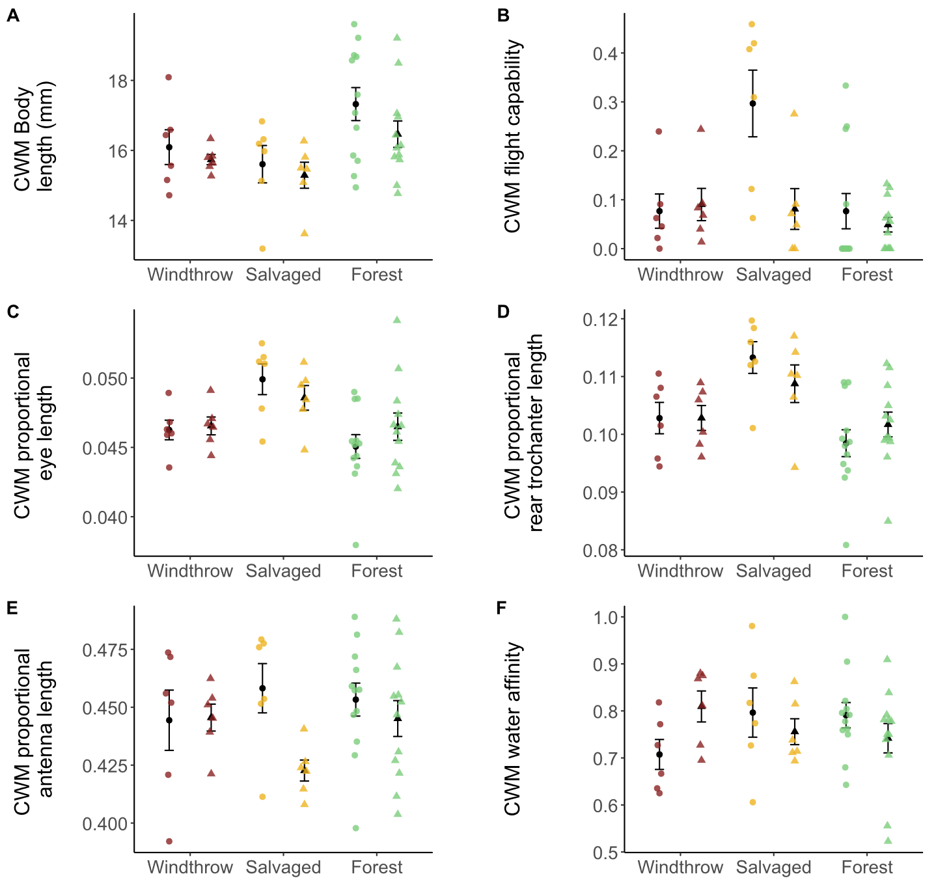

Figure 5. Community-weighted mean (CWM) traits of ground beetles collected in windthrow, salvaged, and undisturbed forest plots in 2015 and 2022. Circular points are observations from 2015, while triangles are observations from 2022. Sample size is 6 plots for windthrow, 6 plots for salvaged, and 12 plots for undisturbed forest. (A) CWM body length, measured as the sum of head length, pronotum length, and elytron length. (B) CWM flight capability, as indicated in the literature (Larochelle and Larivière 2003). Values closer to 1 indicate that a higher proportion of individuals collected were identified as flight-capable species. (C) CWM eye length (posterior to anterior edge of eye) standardized to body length. (D) CWM meta-trochanter length standardized to body length. (E) CWM antenna length standardized to body length. (F) CWM water affinity, as indicated in the literature. Values closer to 1 indicate that a higher proportion of individuals collected belonged to species which prefer wet soil or live near water. A significant effect of forest management treatment was found for A-D, while no significant effects were found for E-F.

Table 3. Main effects of forest management treatments (windthrow, salvaged, undisturbed forest) and year (2015, 2022) on activity-abundance, species richness, species diversity, community-weighted means (CWM) for individual traits, and functional diversity for ground beetles collected at Powdermill Nature Reserve Rector, Westmoreland County, Pennsylvania, USA. The model type column indicates if the model was a standard linear model (LM), a linear mixed-effects model with transect included as a random effect (LMM), or a generalized linear model with Poisson errors (GLM). Dashes indicate that the p-value is above 0.10. Patterns with a p-value below 0.05 are bolded. Beetles were collected between 27 May to 17 August, 2015, and from 1 June to 23 August, 2022.

Response variable |  | Model  type | Treatment  (Windthrow, Salvaged, Forest) |  | Year (2015, 2022) |  | Treatment*Year interaction
 |  |  | Statistic | p | Statistic | p | Statistic | p
Total activity-abundance |  | LMM* | F= 5.7 | 0.007 | F=1.9 | - | F=4.5 | 0.018
Activity abundance of open-habitat or habitat-generalist species |  | LMM* | F=3.6 | 0.037 | F=0.01 | - | F=2.4 | -
Activity abundance of forest-specialist species |  | LMM* | F=0.7 | - | F=3.4 | 0.075 | F=2.7 | 0.079
Species richness |  | GLM | X²=11.5 | 0.003 | X²=2.2 | - | X²=3.2 | -
Shannon diversity |  | LMM | F= 1.0 | - | F= 1.3 | - | F= 0.2 | -
Functional alpha-diversity |  | LM | F=0.4 | - | F= 0.001 | - | F= 1.5 | -
CWM Body length |  | LM | F=5.8 | 0.006 | F=2.6 | - | F=0.3 | -
CWM Standardized antenna length |  | LMM | F=0.6 | - | F=3.9 | 0.056 | F=2.0 | -
CWM Standardized rear leg length |  | LMM | F=0.4 | - | F=1.6 | - | F=1.9 | -
CWM Standardized eye length |  | LMM | F=8.1 | 0.001 | F=0.03 | - | F=1.3 | -
CWM Standardized eye protrusion |  | LMM | F= 1.9 | - | F= 0.3 | - | F= 0.9 | -
CWM Standardized pronotum width |  | LMM | F= 1.2 | - | F= 1.2 | - | F= 0.05 | -
CWM Standardized abdomen width |  | LMM | F= 0.4 | - | F= 0.6 | - | F= 0.6 | -
CWM Standardized rear trochanter length |  | LMM | F= 11.4 | <0.001 | F= 0.05 | - | F= 1.4 | -
CWM Water affinity |  | LM | F=0.1 | - | F= 0.1 | - | F= 2.7 | 0.082
CWM Flight capability |  | LMM* | F= 5.7 | 0.007 | F= 3.5 | 0.068 | F= 3.9 | 0.028
*: a log transformation was done on the response variable to improve the model’s satisfaction of assumptions

Table 4. Means (± standard errors) of the response variables for ground beetle biodiversity.

 |  | Unit |  | Year | Windthrow | Salvaged | Forest
Sample size |  | Plots |  | 2015 | n=6 | n=6 | n=12
 |  |  |  | 2022 | n=6 | n=6 | n=12
Total activity-abundance |  | Beetles per 84 trap days |  | 2015 | 26.8 ± 7.5 | 82.2 ± 24.3 | 26.6 ± 5.4
 |  |  |  | 2022 | 29.2 ± 4.6 | 30.3 ± 8.4 | 22.9 ± 3.3
Activity abundance of open-habitat species |  | Beetles per 84 trap days |  | 2015 | 0 ± 0 | 0.90 ± 0.32 | 0 ± 0
 |  |  |  | 2022 | 0 ± 0 | 0.67 ± 0.67 | 0.23 ± 0.15
Activity abundance of eurytopic species |  | Beetles per 84 trap days |  | 2015 | 12.4 ± 3.6 | 44.2 ± 15.4 | 12.7 ± 3.1
 |  |  |  | 2022 | 15.5 ± 3.6 | 20.2 ± 8.7 | 11.1 ± 1.4
Activity abundance of forest-specialist species |  | Beetles per 84 trap days |  | 2015 | 14.3 ± 4.2 | 37.1 ± 14.3 | 13.9 ± 2.8
 |  |  |  | 2022 | 13.7 ± 3.2 | 9.3 ± 1.9 | 11.6 ± 2.1
Species richness |  | Number of species |  | 2015 | 8.0 ± 1.6 | 11.7 ± 0.8 | 6.7 ± 0.7
 |  |  |  | 2022 | 9.5 ± 1.3 | 9.8 ± 1.1 | 8.3 ± 0.8
Shannon diversity |  | Effective number of species |  | 2015 | 6.5 ± 1.2 | 6.3 ± 1.0 | 5.1 ± 0.5
 |  |  |  | 2022 | 7.0 ± 0.9 | 6.7 ± 1.0 | 6.4 ± 0.6
Functional alpha-diversity |  | Within-plot mean pairwise distance in trait space |  | 2015 | 0.16 ± 0.02 | 0.18 ± 0.01 | 0.15 ± 0.01
 |  |  |  | 2022 | 0.17 ± 0.01 | 0.16 ± 0.01 | 0.17 ± 0.01
CWM Body length |  | mm |  | 2015 | 16.09 ± 0.50 | 15.61 ± 0.53 | 17.32 ± 0.47
 |  |  |  | 2022 | 15.74 ± 0.15 | 15.29 ± 0.37 | 16.46 ± 0.38
CWM Standardized antenna length |  | Fraction of body length |  | 2015 | 0.444 ± 0.013 | 0.458 ± 0.011 | 0.453 ± 0.007
 |  |  |  | 2022 | 0.446 ± 0.006 | 0.423 ± 0.005 | 0.445 ± 0.008
CWM Standardized rear leg length |  | Fraction of body length |  | 2015 | 0.731 ± 0.014 | 0.752 ± 0.013 | 0.744 ± 0.013
 |  |  |  | 2022 | 0.740 ± 0.006 | 0.712 ± 0.008 | 0.739 ± 0.009
CWM Standardized eye length |  | Fraction of body length |  | 2015 | 0.046 ± 0.001 | 0.05 ± 0.001 | 0.045 ± 0.001
 |  |  |  | 2022 | 0.047 ± 0.001 | 0.049 ± 0.001 | 0.046 ± 0.001
CWM Standardized eye protrusion |  | Fraction of body length |  | 2015 | 0.052 ± 0.001 | 0.054 ± 0.001 | 0.051 ± 0.001
 |  |  |  | 2022 | 0.052 ± 0.000 | 0.053 ± 0.001 | 0.052 ± 0.001
CWM Standardized pronotum width |  | Fraction of body length |  | 2015 | 0.263 ± 0.002 | 0.265 ± 0.002 | 0.262 ± 0.003
 |  |  |  | 2022 | 0.265 ± 0.001 | 0.268 ± 0.002 | 0.264 ± 0.001
CWM Standardized abdomen width |  | Fraction of body length |  | 2015 | 0.349 ± 0.006 | 0.351 ± 0.005 | 0.353 ± 0.004
 |  |  |  | 2022 | 0.357 ± 0.003 | 0.349 ± 0.003 | 0.354 ± 0.003
CWM Standardized rear trochanter length |  | Fraction of body length |  | 2015 | 0.103 ± 0.003 | 0.113 ± 0.003 | 0.098 ± 0.002
 |  |  |  | 2022 | 0.103 ± 0.002 | 0.109 ± 0.003 | 0.102 ± 0.002
CWM Water affinity |  | 0, 0.5, or 1 |  | 2015 | 0.71 ± 0.03 | 0.80 ± 0.05 | 0.79 ± 0.03
 |  |  |  | 2022 | 0.81 ± 0.03 | 0.76 ± 0.03 | 0.74 ± 0.03
CWM Flight capability |  | 0, 0.5, or 1 |  | 2015 | 0.08 ± 0.04 | 0.30 ± 0.07 | 0.08 ± 0.04
 |  |  |  | 2022 | 0.09 ± 0.03 | 0.08 ± 0.04 | 0.05 ± 0.01

The taxonomic and functional composition of ground beetle communities differed among forest management treatments (Table 5). Ground beetle communities in salvaged plots were taxonomically distinct from undisturbed forest, and taxonomic composition changed over time from 2015 to 2022 (Fig. 6A). Functional composition showed an interaction between treatment and year, whereby salvaged plots differed from windthrow and undisturbed forest in 2015, but these differences were not detected in 2022 (Fig. 6B). Neither treatment groups nor years differed significantly in dispersion from their spatial medians.

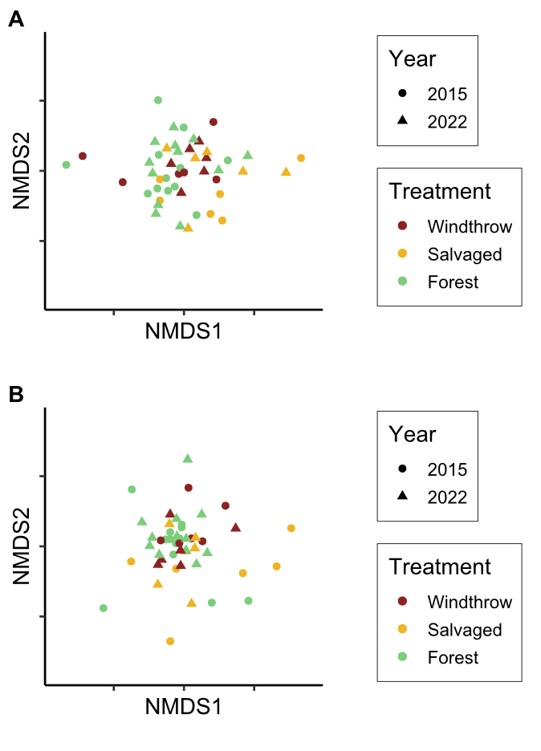
Figure 6. Nonmetric multidimensional scaling (NMDS) ordinations of ground beetle communities in taxonomic space (A) and functional trait space (B). Each point is a plot in a given year; shape of the point indicates the year the community was sampled, while color indicates the forest management treatment. The NMDS ordinations resulted in stress values of 0.224 for taxonomic beta-diversity and 0.181 for functional beta-diversity.

Table 5. Main effects of forest management treatments (windthrow, salvaged, undisturbed forest) and year (2015, 2022) on community composition of ground beetles collected at Powdermill Nature Reserve Rector, Westmoreland County, Pennsylvania, USA. The models use the dissimilarities between plots (Bray-Curtis for taxonomic beta-diversity and inter-community mean pairwise distance in trait space for functional beta-diversity). The PERMANOVA uses the matrix of dissimilarities to partitions how much variation can be explained by treatment, year, and their interaction. The BETADISPER tests whether there are differences between groups in dispersion from the group spatial median. Dashes indicate that the p-value is above 0.10. Patterns with a p-value below 0.05 are bolded

Beta-diversity type |  | Dissimilarity metric | Treatment  (Windthrow, Salvaged, Forest) |  | Year (2015, 2022) |  | Treatment*Year interaction
 |  |  | Statistic | p | Statistic | p | Statistic | p
Taxonomic  PERMANOVA |  | Bray-Curtis | F=1.7 | 0.019 | F=3.8 | <0.001 | F=1.0 | -
Taxonomic  BETADISPER |  | Bray-Curtis | F=0.6 | - | F=0.3 | - | Not  tested | Not tested
Functional  PERMANOVA |  | comdist* | F=1.6 | 0.001 | F=1.3 | 0.078 | F=1.3 | 0.046
Functional BETADISPER |  | comdist* | F=0.7 | - | F=2.8 | - | Not tested | Not tested
* : inter-community mean pairwise distance in trait space

The forest floor environment changed among the forest management treatments over time (Tables 6-7). In 2015, canopy openness was higher above salvaged plots than windthrow or undisturbed forest plots. By 2022, canopy openness above salvaged plots had decreased, but remained higher, on average, than forest plots. In 2015, salvaged plots had higher vegetation cover than windthrow, and windthrow had higher vegetation cover than forest controls, but these patterns had almost disappeared by 2022. Meanwhile, percentage cover of leaf litter showed the opposite pattern. In 2015, salvaged plots had the lowest leaf litter cover, followed by windthrow plots and then forest controls with the highest leaf litter cover. By 2022, these differences had mostly, but not entirely, disappeared. Soil moisture was similar among forest management treatments, both in 2015 and in 2022.

Table 6. Main effects of forest management treatments (windthrow, salvaged, undisturbed forest) and year (2015, 2022) on environmental variables in the understory at Powdermill Nature Reserve, Rector, Westmoreland County, Pennsylvania, USA. All models were linear mixed-effects models with transect included as a random effect (LMM). Dashes indicate that the p-value is above 0.10. Patterns with a p-value below 0.05 are bolded.

Response variable |  | Model  type | Treatment  (Windthrow, Salvaged, Forest) |  | Year (2015, 2022) |  | Treatment*Year interaction
 |  |  | Statistic | p | Statistic | p | Statistic | p
Canopy openness |  | LMM* | F=47.2 | <0.001 | F=45.9 | <0.001 | F=19.9 | <0.001
Vegetation percentage cover |  | LMM | F=15.6 | <0.001 | F=0.7 | - | F=5.7 | 0.007
Leaf litter percentage cover |  | LMM | F=20.0 | <0.001 | F= 0.8 | - | F=8.8 | 0.001
Soil moisture (2015) |  | LMM | F=0.08 | - | Not tested | Not tested | Not tested | Not tested
Soil moisture (2022) |  | LMM | F=0.2 | - | Not tested | Not tested | Not tested | Not tested
*: a log transformation was done on the response variable to improve the model’s satisfaction of assumptions

Table 7. Means (± standard errors) of the environmental variables in the understory.

 |  | Unit |  | Year | Forest | Salvaged | Windthrow
Canopy openness |  | 0-100% |  | 2015 | 9.1 ± 0.4 | 82.3 ± 3.4 | 13.7 ± 2.5
 |  |  |  | 2022 | 7.7 ± 0.5 | 19.7 ± 10.8 | 9.1 ± 1.3
Ground-level vegetation percentage cover |  | 0-100% |  | 2015 | 21.6 ± 2.8 | 73.0 ± 6.0 | 42.1 ± 10.4
 |  |  |  | 2022 | 35.1 ± 4.2 | 47.7 ± 11.3 | 41.9 ± 6.7
Leaf litter percentage cover |  | 0-100% |  | 2015 | 61.2 ± 3.6 | 5.2 ± 3.5 | 35.4 ± 7.3
 |  |  |  | 2022 | 43.1 ± 4.5 | 31.5 ± 9.5 | 39.6 ± 5.8
Soil moisture$ |  | 0-1.129 |  | 2015 | 0.59 ± 0.04 | 0.61 ± 0.07 | 0.60 ± 0.04
 |  | 0-100% |  | 2022 | 44.8 ± 3.5 | 47.6 ± 2.5 | 48.7 ± 7.4
$: A different soil sensor was used in 2022 than was used in 2015, so readings are only comparable between treatments within a year.

Discussion

This study investigated the effects of disturbance caused by wind and subsequent salvage logging on ground beetle communities over time. We found that ground beetles differed both taxonomically and functionally between windthrow and salvaged forest, consistent with other studies (Koivula and Spence 2006, Gandhi et al. 2008). Salvage-logging, which removed all standing and downed trees, supported ground beetle communities that were distinct in species and trait composition compared to windthrow and undisturbed forest which were more similar to one another. Although differences between treatments were largest two years after salvaging in 2015, some differences in species and traits persisted even in 2022, nine years after salvaging. This suggests that, similarly to the effects of green logging (Niemelä et al. 2007), the impacts of salvage logging after a natural disturbance continue to affect forest invertebrates for more than a decade, even as tree regeneration begins.

Patterns of taxonomic diversity:

Windthrows which were not subjected to salvaging were similar to undisturbed forest in species richness, activity-abundance, and community composition, in both 2015 and 2022. This finding was inconsistent with our hypothesis that alpha-diversity would increase in unsalvaged windthrows relative to undisturbed forest. Other studies of unsalvaged windthrows have found slightly elevated alpha-diversity and altered community composition relative to reference forest (Gandhi et al. 2008, Sklodowski and Garbalinska 2011, Barber and Widick 2017). In particular, the increase in dying and dead trees, changes in abiotic conditions, and increased ground-level vegetation should alter communities of a wide variety of arthropod taxa (Urbanovicova et al. 2014, Wermelinger et al. 2017). However, instead of a complete reorganization of the ground beetle community, windthrows commonly support many of the same species found in undisturbed forest (Lee et al. 2017). Similarly, our study saw the persistence of forest-specialists rather than any pronounced influx of new species. This can be explained by the canopy openness data, which shows that the openness above windthrow plots was only slightly higher than undisturbed forest, meaning many canopy trees survived the initial windstorm in 2012.

In contrast to windthrow alone, we found that salvage-logging resulted in distinct ground beetle communities and elevated species richness relative to undisturbed forest. Habitat-generalists increased in abundance in salvaged plots at two years after salvaging, dramatically altering community composition, which supports our initial hypothesis. At nine years after salvaging, ground beetle communities remained taxonomically distinct, suggesting that legacies of windthrow were altered by the logging process. Our results align with many studies of salvage-logging and green-logging, where complete canopy removal results in an initial influx of new species (Pearce et al. 2003, Niemelä et al. 2007, Silverman et al. 2008, Gandhi et al. 2008). However, in our case, the new species were usually habitat generalists, like C. emarginatus, whereas other studies have found abundant open-habitat specialists from the genera Amara and Harpalus (Pearce et al. 2003, Silverman et al. 2008, Riley and Browne 2011). This finding may reflect the surrounding landscape, which is mostly forested and likely did not support source populations of open-habitat species. We also found some forest-specialists, such as P. moestus, thrived initially in salvage-logged habitat, which may indicate their ability to tolerate altered abiotic conditions (Riley and Browne 2011), adopt new food sources (Lee et al. 2017), utilize any rapidly decomposing branches left by salvaging (Hamilton 1884, Thorn et al. 2014), or travel back and forth between salvaged and unsalvaged habitat during different times of the year (Ohwaki et al. 2015). However, it is unclear whether these forest-specialists will persist in the long-term in salvaged plots, as the logging may result in low woody debris volume, a resource that is valuable to many species (Gore and Patterson III 1986, Pearce et al. 2003).

Patterns of functional diversity:

Contrary to our hypothesis, we found that functional alpha-diversity was similar among forest management treatments and across years, despite the increase in species richness in salvaged plots. We expected that the influx of open-habitat species and habitat-generalists following windthrow and salvage-logging would increase functional diversity due to the influx of species with novel traits such as flight capability or traits associated with specialized modes of feeding (Lee et al. 2017, Nardi et al. 2022). However, our results suggest that, because a few habitat-generalist species were extremely abundant in salvaged plots, this lowered the functional alpha-diversity, as measured by weighted mean pairwise distance in trait space. Similarly, a study of forest management after a Minnesota windstorm found that prescribed burning resulted in the proliferation of a single species of habitat generalist (Gandhi et al. 2008). Although windthrow and salvage-logging disturbances supported similar functional alpha-diversity to undisturbed forest, beta-diversity analyses showed that salvaged forest was distinct in ground beetle traits in 2015. The environmental conditions within salvaged plots, including higher light levels, lower leaf litter depth (Greenberg and Forrest 2003), temperature extremes (Urbanovicova et al. 2014), altered vegetation (Spicer et al. 2023), and changes in prey types (Wermelinger et al. 2017) can act as filters that select for a different suite of functional traits (Bauer and Kredler 1993, Inward et al. 2011, Ng et al. 2018).

We predicted that species common in salvaged plots initially after disturbance would have proportionally larger eyes, higher flight capability, and higher soil moisture preference than species common in unsalvaged windthrow or undisturbed forest. We found that species common in salvaged forest displayed proportionally longer eyes, and higher flight capability in 2015, but CWM water affinity did not differ. Other studies have documented increases in flight capable ground beetle species following forest disturbances (Sklodowski and Garbalinska 2011, Sultaire et al. 2021, Nardi et al. 2022). The abundance of flight-capable species typically increases in the first few years after disturbance, then decreases over multiple decades of forest regeneration (Sklodowski and Garbalinska 2011, Riley and Browne 2011). Species with proportionally larger eyes may have thrived in the high-sunlight salvaged-logged forest, as larger eye size is related to open habitat preference, diurnal activity, and visual-hunting strategy (Bauer and Kredler 1993, Ribera et al. 1999, Talarico et al. 2007). We did not find differences in soil moisture preference, which is also reflected in the environmental data, in which soil moisture did not differ between forest management treatments in either year. Similarly, another study in Tennessee did not find differences in soil moisture between lightly salvaged and unsalvaged windthrows, although it was highly variable between pit and mound microsites (Peterson and Leach 2008).

We found that species common in undisturbed forest tended to have larger bodies than species common in disturbed areas, as measured by body length. Body size can relate to multiple life-history traits, including dispersal, prey choice, interspecific competition, and the ability to move through fine-grained substrates. Body size is related to dispersal in multiple ways, because larger beetles may be able to walk farther on foot (Venn 2016), but flight may be more energetically expensive for heavy species. Body size can influence prey choice, as larger species may prey on stronger prey items such as large caterpillars (Thiele 1977). Furthermore, body size can influence interspecific competition, because two species are more likely to compete for similar food resources if they are the same size (Spence 1979, Lenski 1982). Body size can also relate to the microhabitat that a species moves through (Weiser and Kaspari 2006). For example, species that move within small crevices may have selection pressure for smaller size (Ng et al. 2018). In our study, undisturbed forest had the highest percentage cover of leaf litter and the lowest percent cover of vegetation. It is possible that the increased ground-level vegetation in disturbed forest impeded the movement of larger species.

We found that salvage-logging caused an increase in CWM proportional rear trochanter length. This trait is particularly important for separating species into categories based on their locomotion. Surface walkers and surface runners (group I) are a functional group having shorter rear trochanters, while “wedge-pushers” or species that push through substrates (group II) are a group characterized by longer (and larger) rear trochanters (Evans 1977). While most of the species in our study were in group II, a few species, such as those in the tribes Carabini, Cychrini, and Notiophilini, are group I with short trochanters (Figure S5) (Forsythe 1981). Sphaeroderus sp. and Scaphinotus sp. use their palpi to track gastropod trails, while Carabus goryi eats soft-bodied insect larvae (Lenski 1982, Larochelle and Larivière 2003). The elevation of CWM trochanter length in salvaged plots may reflect both a decline in abundance of surface-walker species and an increase in generalist group II species. Because this trait exhibited differences both in 2015 and 2022, it indicates that the legacy of anthropogenic disturbance continued to be detectable in beetle communities nine years after salvage-logging. Another study of green-logging in the Pacific Northwest similarly found negative effects on snail-eating beetles in the subfamily Cychrini, which was detected by changes in the functional diversity of mandible shapes (Sultaire et al. 2021). Furthermore, two studies have reported that C. goryi is negatively affected by clearcutting (Lenski 1982, Silverman et al. 2008).

What it means for forest management:

We documented how forest management after a windstorm impacts ground beetle biodiversity. Sampling both three years and ten years after the tornado allowed us to observe that beetle communities and abiotic conditions changed over time. The effects of salvage-logging in the short term, such as increases in sunlight, altered size-distribution of tree seedlings (Slyder et al. 2020), alterations of the sizes and microclimates around woody debris (Thorn et al. 2014), and increases in herbaceous plant richness and shrub abundance (Spicer et al. 2023), may not be the same as long-term changes. However, we still observed differences between treatments in the ground beetle communities after a decade, which reinforces other research that salvage-logging effects last longer than 20 years and possibly 100 years or more (Thorn et al. 2020). Particularly, saproxylic taxa that inhabit naturally disturbed forests are most sensitive to the effects of salvage logging (Thorn et al. 2014, 2018). Some forest species may be able to cope with the effects of salvage-logging, whereas others will thrive in naturally disturbed forest that is left intact (Koivula and Spence 2006).

Supplementary information

Omission of the final two sampling intervals of 2022

In 2022, pitfall traps were sampled into September, but these final two sample intervals were omitted from the analysis. Because we only had September data in 2022, but not for 2015, we decided to omit the September 2022 data to ensure that the two years could be comparable. The species composition of ground beetles found in pitfall traps changed in September. For example, the following species were found only in September 2022, and not earlier in 2022 or in 2015: Amerizus sp. (Bembidiini), Myas coracinus, Patrobus longicornis, Platynus hypolithos, Pterostichus atratus, Scaphinotus andrewsii, Scaphinotus ridingsii, and Synuchus impunctatus. Furthermore, the abundance of some species, including Platynus angustatus, greatly increased in September (Figure S1). This evidence further justifies our omission of the final two sample intervals of 2022 from the statistical analysis.

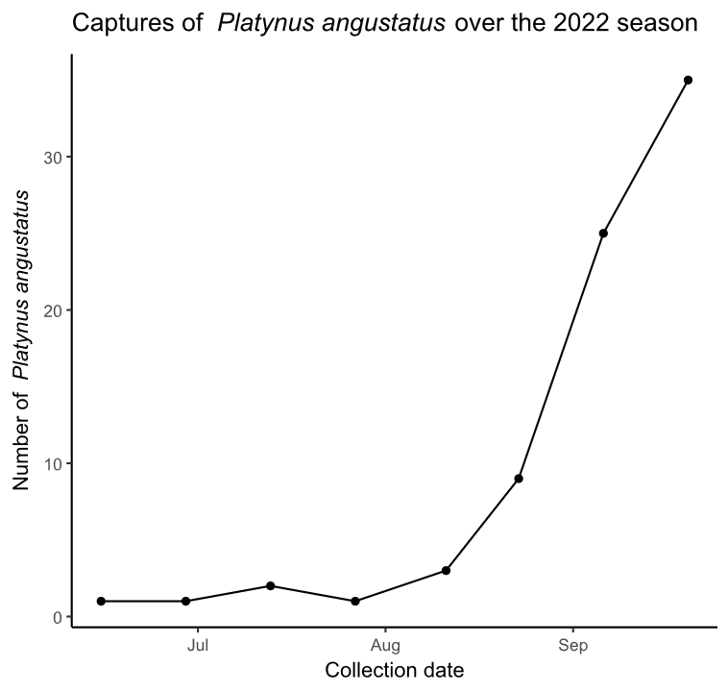
Figure S1. Captures of Platynus angustatus over the 2022 season in all pitfall traps. The x-axis shows the date of collection, while the y-axis shows number of P. angustatus captured during the sample interval.

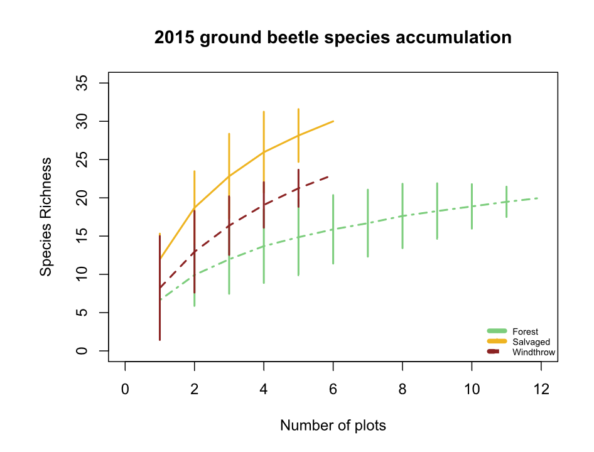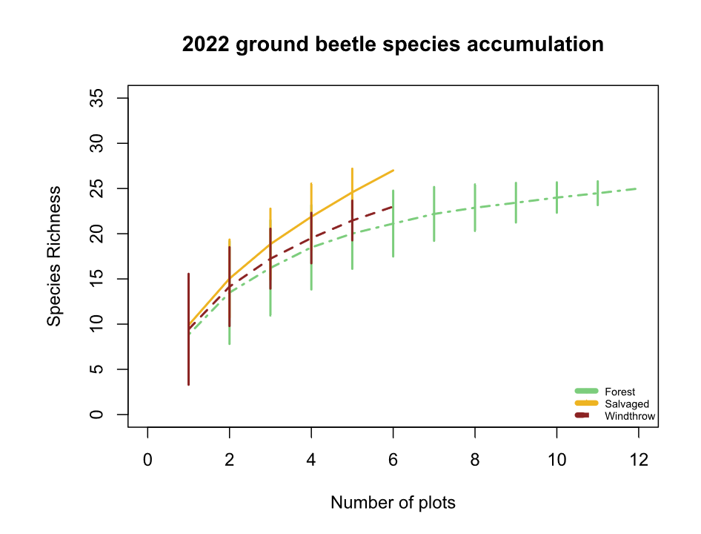
B
A
Figure S2. Species accumulation curves for A) 2015 ground beetles and B) 2022 ground beetles. The x-axis shows the number of sampled plots, while the y-axis shows the species richness.

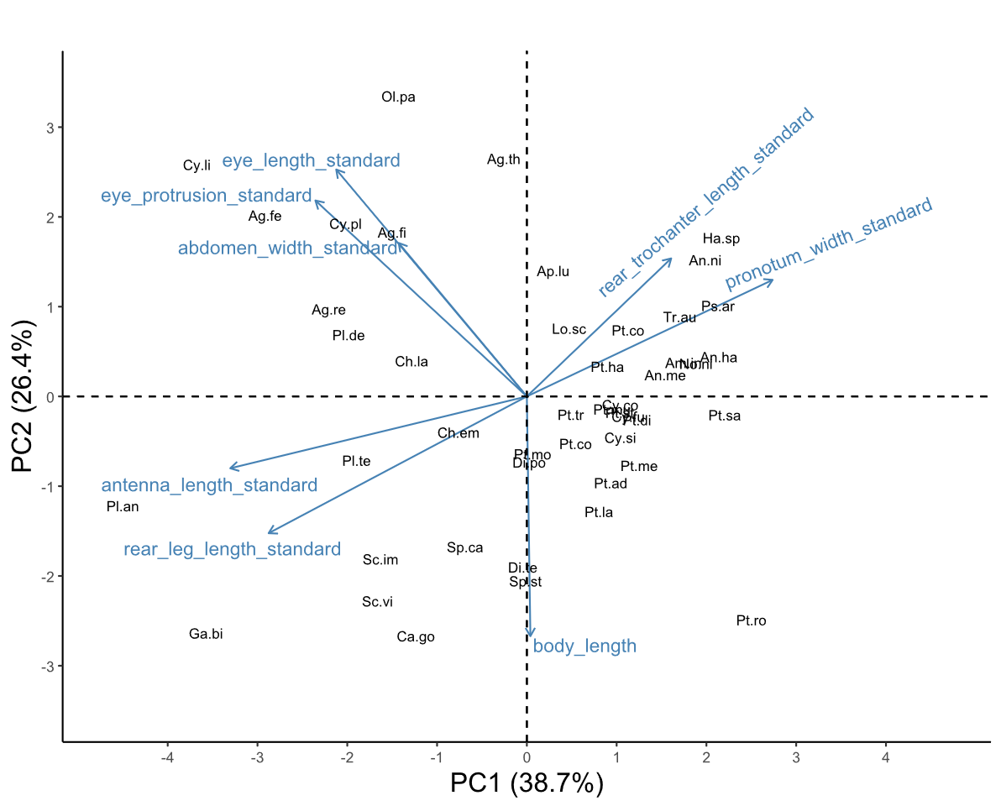
Figure S3. Biplot of the first two principal component axes of the principal components analysis (PCA) of the eight numerical traits measured for 47 ground beetle species. Blue arrows with labels are the eight trait variables, which are explained in Table 1. Black text in the graph indicates the locations of each species in trait space, following the abbreviations in Table 2. The word “standard” after a variable name indicates that it has previously been divided by body length to address high correlations with body length. The species Notiophilus aeneus was omitted from the PCA.
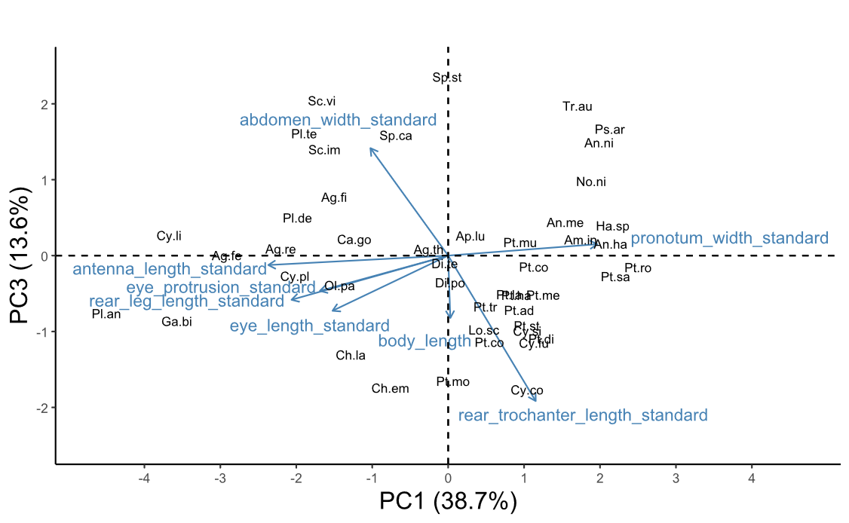
Figure S4. Biplot of the third principal component axis (y-axis) against the first principal component axis (x-axis) of the principal components analysis (PCA) of the eight numerical traits measured for 47 ground beetle species. Blue arrows with labels are the eight trait variables, which are explained in Table 1. Black text in the graph indicates the locations of each species in trait space, following the abbreviations in Table 2. The word “standard” after a variable name indicates that it has previously been divided by body length to address high correlations with body length. The species Notiophilus aeneus was omitted from the PCA.

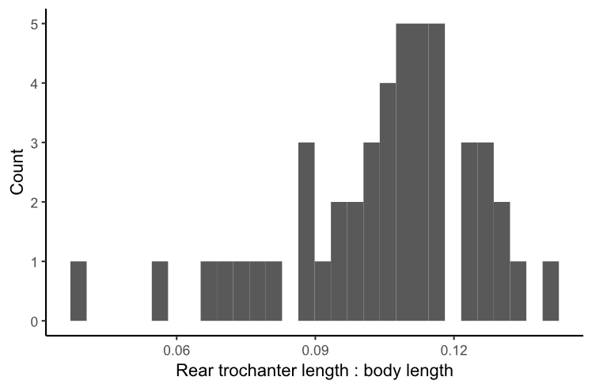
Figure S5. Histogram of proportional rear trochanter lengths of 47 species of ground beetles. The x-axis is the ratio of rear trochanter length to body length, while the y-axis is the number of species in each bin.

Table S1. Voucher specimens used for trait measurements in this study. The Unique ID begins with “OSUC” if the specimen was already in the Ohio State University Triplehorn Insect Collection from 2015 or a previous study, whereas Unique IDs with just a number indicate 2022 specimens which will be vouchered as part of this study.
Species | Sex | Unique ID | Location of collection
Agonoleptus thoracicus | f | 819611 | Powdermill
Agonum ferreum | m | OSUC 671705 | Powdermill
Agonum ferreum | m | OSUC 671700 | Powdermill
Agonum ferreum | f | OSUC 671704 | Powdermill
Agonum ferreum | f | OSUC 671703 | Powdermill
Agonum ferreum | f | OSUC 671702 | Powdermill
Agonum fidele | f | 819619 | Powdermill
Agonum fidele | f | 819616 | Powdermill
Agonum fidele | f | 819613 | Powdermill
Agonum retractum | m | OSUC 671697 | Powdermill
Agonum retractum | f | OSUC 523212 | Erie Co. OH
Agonum retractum | f | OSUC 523213 | Erie Co. OH
Agonum retractum | f | OSUC 523214 | Erie Co. OH
Amerizus sp. | m | 819614 | Powdermill
Amphasia interstitialis | m | Not vouchered | Powdermill
Amphasia interstitialis | f | Not vouchered | Powdermill
Amphasia interstitialis | f | Not vouchered | Powdermill
Amphasia interstitialis | f | Not vouchered | Powdermill
Anisodactylus harrisii | m | OSUC 671671 | Powdermill
Anisodactylus harrisii | m | OSUC 740908 | Cuyahoga Co. OH
Anisodactylus harrisii | m | OSUC 740906 | Cuyahoga Co. OH
Anisodactylus harrisii | f | 819778 | Powdermill
Anisodactylus harrisii | f | OSUC 740902 | Cuyahoga Co. OH
Anisodactylus harrisii | f | OSUC 740900 | Cuyahoga Co. OH
Anisodactylus melanopus | m | 819699 | Powdermill
Anisodactylus nigerrimus | m | 819634 | Powdermill
Anisodactylus nigerrimus | m | 819631 | Powdermill
Anisodactylus nigerrimus | m | 819628 | Powdermill
Anisodactylus nigerrimus | f | 819625 | Powdermill
Anisodactylus nigerrimus | f | 819622 | Powdermill
Apenes lucidula | m | 819706 | Powdermill
Apenes lucidula | m | 819715 | Powdermill
Apenes lucidula | f | 819707 | Powdermill
Apenes lucidula | f | 819716 | Powdermill
Apenes lucidula | f | 819724 | Powdermill
Carabus goryi | m | 819636 | Powdermill
Carabus goryi | m | 819639 | Powdermill
Carabus goryi | m | 819642 | Powdermill
Carabus goryi | f | 819645 | Powdermill
Carabus goryi | f | 819648 | Powdermill
Carabus goryi | f | 819651 | Powdermill
Chlaenius emarginatus | m | 819704 | Powdermill
Chlaenius emarginatus | m | 819713 | Powdermill
Chlaenius emarginatus | m | 819722 | Powdermill
Chlaenius emarginatus | f | 819705 | Powdermill
Chlaenius emarginatus | f | 819714 | Powdermill
Chlaenius emarginatus | f | 819723 | Powdermill
Chlaenius laticollis | f | OSUC 671794 | Powdermill
Chlaenius laticollis | f | OSUC 671795 | Powdermill
Cyclotrachelus convivus | m | OSUC 671699 | Powdermill
Cyclotrachelus convivus | m | OSUC 522517 | Erie Co. OH
Cyclotrachelus convivus | m | OSUC 740962 | Cuyahoga Co. OH
Cyclotrachelus convivus | f | OSUC 522528 | Erie Co. OH
Cyclotrachelus convivus | f | OSUC 522527 | Erie Co. OH
Cyclotrachelus convivus | f | OSUC 522525 | Erie Co. OH
Cyclotrachelus fucatus | m | 819782 | Powdermill
Cyclotrachelus sigillatus | m | 819753 | Powdermill
Cyclotrachelus sigillatus | m | 819763 | Powdermill
Cyclotrachelus sigillatus | m | 819773 | Powdermill
Cyclotrachelus sigillatus | f | 819754 | Powdermill
Cyclotrachelus sigillatus | f | 819764 | Powdermill
Cyclotrachelus sigillatus | f | 819774 | Powdermill
Cymindis limbata | unknown sex | 819617 | Powdermill
Cymindis platicollis | unknown sex | 819777 | Powdermill
Dicaelus politus | m | 819708 | Powdermill
Dicaelus politus | m | 819717 | Powdermill
Dicaelus politus | m | 819725 | Powdermill
Dicaelus politus | f | 819709 | Powdermill
Dicaelus politus | f | 819718 | Powdermill
Dicaelus politus | f | 819726 | Powdermill
Dicaelus teter | m | 819604 | Powdermill
Dicaelus teter | m | 819719 | Powdermill
Dicaelus teter | m | 819727 | Powdermill
Dicaelus teter | f | 819710 | Powdermill
Dicaelus teter | f | 819720 | Powdermill
Dicaelus teter | f | 819728 | Powdermill
Galerita bicolor | f | 819640 | Powdermill
Galerita bicolor | f | 819637 | Powdermill
Harpalus spadiceus | m | 819658 | Powdermill
Harpalus spadiceus | m | 819655 | Powdermill
Harpalus spadiceus | m | 819652 | Powdermill
Harpalus spadiceus | f | 819649 | Powdermill
Harpalus spadiceus | f | 819646 | Powdermill
Harpalus spadiceus | f | 819643 | Powdermill
Lophoglossus scrutator | m | 819780 | Powdermill
Myas coracinus | m | 819733 | Powdermill
Myas coracinus | f | 819734 | Powdermill
Notiobia nitidipennis | m | 672665 | Powdermill
Notiobia nitidipennis | m | 672659 | Powdermill
Notiobia nitidipennis | m | 672651 | Powdermill
Notiobia nitidipennis | f | 672663 | Powdermill
Notiobia nitidipennis | f | 672662 | Powdermill
Notiobia nitidipennis | f | 672661 | Powdermill
Notiophilus aeneus | m | 819608 | Powdermill
Olisthopus parmatus | f | 819630 | Powdermill
Olisthopus parmatus | f | 819633 | Powdermill
Olisthopus parmatus | f | OSUC 672763 | Powdermill
Olisthopus parmatus | m | OSUC 672759 | Powdermill
Olisthopus parmatus | m | OSUC 672760 | Powdermill
Patrobus longicornis | f | 819693 | Powdermill
Platynus angustatus | m | 819612 | Powdermill
Platynus angustatus | m | 819615 | Powdermill
Platynus angustatus | m | 819618 | Powdermill
Platynus angustatus | f | 819621 | Powdermill
Platynus angustatus | f | 819624 | Powdermill
Platynus angustatus | f | 819627 | Powdermill
Platynus decentis | m | 819687 | Powdermill
Platynus hypolithos | m | 819690 | Powdermill
Platynus tenuicollis | m | 819610 | Powdermill
Platynus tenuicollis | m | 819607 | Powdermill
Platynus tenuicollis | f | 819603 | Powdermill
Platynus tenuicollis | f | 819606 | Powdermill
Platynus tenuicollis | f | 819609 | Powdermill
Pseudamara arenaria | f | 819605 | Powdermill
Pseudamara arenaria | f | OSUC 671695 | Powdermill
Pterostichus adoxus | m | 819749 | Powdermill
Pterostichus adoxus | m | 819759 | Powdermill
Pterostichus adoxus | m | 819769 | Powdermill
Pterostichus adoxus | f | 819750 | Powdermill
Pterostichus adoxus | f | 819760 | Powdermill
Pterostichus adoxus | f | 819770 | Powdermill
Pterostichus atratus | m | 819735 | Powdermill
Pterostichus atratus | f | 819736 | Powdermill
Pterostichus coracinus | m | 819751 | Powdermill
Pterostichus coracinus | m | 819761 | Powdermill
Pterostichus coracinus | m | 819771 | Powdermill
Pterostichus coracinus | f | 819752 | Powdermill
Pterostichus coracinus | f | 819762 | Powdermill
Pterostichus coracinus | f | 819772 | Powdermill
Pterostichus corvinus | m | OSUC 671808 | Powdermill
Pterostichus corvinus | f | OSUC 671807 | Powdermill
Pterostichus corvinus | f | OSUC 671809 | Powdermill
Pterostichus corvinus | f | OSUC 671810 | Powdermill
Pterostichus diligendus | m | 819781 | Powdermill
Pterostichus hamiltoni | m | 819779 | Powdermill
Pterostichus lachrymosus | m | 819682 | Powdermill
Pterostichus lachrymosus | m | 819679 | Powdermill
Pterostichus lachrymosus | m | 819676 | Powdermill
Pterostichus lachrymosus | f | 819673 | Powdermill
Pterostichus lachrymosus | f | 819670 | Powdermill
Pterostichus lachrymosus | f | 819667 | Powdermill
Pterostichus melanarius | m | OSUC 522968 | Erie Co. OH
Pterostichus melanarius | m | OSUC 522969 | Erie Co. OH
Pterostichus melanarius | m | OSUC 668451 | Powdermill
Pterostichus melanarius | f | OSUC 740950 | Cuyahoga Co. OH
Pterostichus moestus | m | 819737 | Powdermill
Pterostichus moestus | m | 819741 | Powdermill
Pterostichus moestus | m | 819745 | Powdermill
Pterostichus moestus | f | 819738 | Powdermill
Pterostichus moestus | f | 819742 | Powdermill
Pterostichus moestus | f | 819746 | Powdermill
Pterostichus mutus | m | OSUC 522813 | Erie Co. OH
Pterostichus mutus | m | OSUC 671803 | Powdermill
Pterostichus mutus | m | OSUC 671804 | Powdermill
Pterostichus mutus | f | OSUC 522811 | Erie Co. OH
Pterostichus mutus | f | OSUC 671805 | Powdermill
Pterostichus mutus | f | OSUC 671801 | Powdermill
Pterostichus rostratus | m | 819729 | Powdermill
Pterostichus rostratus | m | 819739 | Powdermill
Pterostichus rostratus | m | 819743 | Powdermill
Pterostichus rostratus | f | 819730 | Powdermill
Pterostichus rostratus | f | 819740 | Powdermill
Pterostichus rostratus | f | 819744 | Powdermill
Pterostichus sayanus | m | 819731 | Powdermill
Pterostichus sayanus | f | 819732 | Powdermill
Pterostichus stygicus | m | 819755 | Powdermill
Pterostichus stygicus | m | 819765 | Powdermill
Pterostichus stygicus | m | 819775 | Powdermill
Pterostichus stygicus | f | 819756 | Powdermill
Pterostichus stygicus | f | 819766 | Powdermill
Pterostichus stygicus | f | 819776 | Powdermill
Pterostichus tristis | m | 819747 | Powdermill
Pterostichus tristis | m | 819757 | Powdermill
Pterostichus tristis | m | 819767 | Powdermill
Pterostichus tristis | f | 819748 | Powdermill
Pterostichus tristis | f | 819758 | Powdermill
Pterostichus tristis | f | 819768 | Powdermill
Scaphinotus andrewsii | m | 819660 | Powdermill
Scaphinotus andrewsii | f | 819663 | Powdermill
Scaphinotus imperfectus | m | 819672 | Powdermill
Scaphinotus imperfectus | m | 819675 | Powdermill
Scaphinotus imperfectus | m | 819678 | Powdermill
Scaphinotus imperfectus | f | 819681 | Powdermill
Scaphinotus imperfectus | f | 819684 | Powdermill
Scaphinotus ridingsii | m | 819666 | Powdermill
Scaphinotus ridingsii | m | 819669 | Powdermill
Scaphinotus viduus | m | 819654 | Powdermill
Scaphinotus viduus | m | 819657 | Powdermill
Sphaeroderus canadensis | m | 819702 | Powdermill
Sphaeroderus canadensis | m | 819711 | Powdermill
Sphaeroderus canadensis | f | 819703 | Powdermill
Sphaeroderus canadensis | f | 819712 | Powdermill
Sphaeroderus canadensis | f | 819721 | Powdermill
Sphaeroderus stenostomus | m | 819700 | Powdermill
Sphaeroderus stenostomus | m | 819697 | Powdermill
Sphaeroderus stenostomus | m | 819694 | Powdermill
Sphaeroderus stenostomus | f | 819691 | Powdermill
Sphaeroderus stenostomus | f | 819688 | Powdermill
Sphaeroderus stenostomus | f | 819685 | Powdermill
Synuchus impunctatus | f | 819696 | Powdermill
Trichotichnus autumnalis | f | 819664 | Powdermill
Trichotichnus autumnalis | f | 819661 | Powdermill

Table S2. Loading values for the first four principal components of eight numerical traits. Percentages underneath each PC column indicate the percentage of variance explained by each axis. The word “standard” after a variable name indicates that it has previously been divided by body length.
Trait | PC1 (39%) | PC2 (26%) | PC3 (14%) | PC4 (11%)
body_length | 0.01 | -0.5 | -0.3 | 0.57
antenna_length_standard | -0.51 | -0.15 | -0.05 | -0.05
eye_protrusion_standard | -0.37 | 0.41 | -0.17 | 0.25
eye_length_standard | -0.33 | 0.48 | -0.27 | -0.21
pronotum_width_standard | 0.43 | 0.24 | 0.06 | 0.4
abdomen_width_standard | -0.22 | 0.32 | 0.52 | 0.58
rear_leg_length_standard | -0.45 | -0.29 | -0.21 | 0.21
rear_trochanter_length_standard | 0.25 | 0.29 | -0.7 | 0.17

Table S3. Comparison of the principal component analyses (PCA) run with and without Notiophilus aeneus, a species with unusual traits. Traits were listed under “Top loading values” if their loading value was ≥ 0.4. The word “standard” after each trait indicates that these values have been divided by body length prior to running the PCA.
 | PCA with Notiophilus aeneus | PCA excluding Notiophilus aeneus (used in further analyses)
Variance explained by PC1 | 33.1 % | 38.7 %
Variance explained by PC2 | 30.2 % | 26.4 %
Variance explained by PC3 | 14.0 % | 13.6 %
Top loading values for PC1 | antenna_length_standard (+0.53),  pronotum_width_standard (-0.50),  rear_leg_length_standard (+0.54) | antenna_length_standard (-0.51),  pronotum_width_standard (+0.43),  rear_leg_length_standard (-0.45)
Top loading values for PC2 | body_length (-0.41),  eye_protrusion_standard (+0.58),  eye_length_standard (+0.59), | body_length (-0.50),  eye_protrusion_standard (+0.41),  eye_length_standard (+0.48)
Top loading values for PC3 | abdomen_width_standard (-0.85) | abdomen_width_standard (+0.52)  rear_trochanter_length_standard (-0.70)

Table S4. Specific definitions of the traits measured for ground beetles in this study. Literature-based traits were found using (Larochelle and Larivière 2003). Morphological traits were measured using an ocular micrometer. Sometimes multiple measurements were added to obtain a morphological trait. For example, body length was defined as elytron length + pronotum length + head length.

Literature-based traits |  |  | Definition
Forest_affinity |  |  | Three options: forest specialist, open habitat, or eurytopic. Mark forest specialist if Larochelle and Lariviere (2003) only mention forested areas and/or shaded ground as a habitat. Mark open habitat if they only mention clearings, pastures, or fields, and/or if they only mention unshaded ground or open habitat. Mark eurytopic if both habitat affinities are mentioned, such as "forest clearings" or "shaded or open ground" or "roads and edges".
Water_affinity |  |  | Water affinity was coded as 0 for xerophilous species, 1 for hygrophilous species, and 0.5 for intermediate species. If the description mentions wet soil or proximity to waterway or lakes, then mark 1 (hygrophilous). If description mentions moist soil, then 0.5 (intermediate). If description mentions dry soil, then 0 (xerophilous).
Flight_capability |  |  | Flight capability was coded as 1 if the species is flight-capable, 0 if the species is flight-incapable, and 0.5 if the species exhibits wing dimorphism. Taken from Larochelle and Lariviere (2003) rather than from the specimens.
Trait | Measured components | Unit | Definition
Body_length |  | mm | Elytra_length + Pronotum_length + Head_length
 | Elytra_length | mm | Distance, along 1st elytral interval, from posterior edge of pronotum to posterior edge of elytra - not including the abdomen if it extends past elytra. The anterior 1/2 of the elytra should be horizontal.
 | Pronotum_length | mm | Distance, along midline, from anterior to posterior end of pronotum
 | Head_length | mm | Distance from tip of mandibles to anterior end of pronotum (follows Bousquet 2010). If mandibles are unequal in length, I'm taking the distance from the longer of the mandibles. I'm pitching the beetle up so that the mandibles are at roughly the same height as the frons.
Antenna_length |  | mm | Distance from the base to tip of antenna. Choose the left or right antenna depending on which is less curved and which one is not missing any segments. If necessary, divide the antenna into parts and add up the lengths.
Eye_protrusion |  | mm | Outer_eye_distance - Inner_eye_distance
 | Outer_eye_distance | mm | Distance between apical sides of each compound eye, EVEN if the head behind or around the eyes is slightly wider than the measured distance (example: Pterostichus rostratus)
 | Inner_eye_distance | mm | Looking down at the dorsal surface of the beetle's head, find the minimum separation between the interior edges of the compound eyes
Eye_length |  | mm | Look at beetle in profile. Turn the beetle so the rounded part of the eye is pointing straight up towards the lens of the microscope. Then measure from the anterior to posterior of the part covered in ommatidia. Measure along the direction from lateral pronotal edge to mandibles
Pronotum_width |  | mm | Distance between marginal sides of pronotum at their widest point
Abdomen_width |  | mm | Distance between marginal sides of elytra or abdomen at widest point. If the elytra are widely separated, then measure width of one elytron and multiply by 2.
Rear_leg_length |  | mm | Rear_femur_length + Rear_tibia_length + Rear_tarsi_length
 | Rear_femur_length | mm
 | Rear_tibia_length | mm | Distance from (the center of the apex of the femur) to end of tibia, not including tibial spurs
 | Rear_tarsi_length | mm | If necessary, measure each tarsal segment and add them up. Do not include tarsal claws.
Rear_trochanter_length |  | mm | Length of the bean-shaped rear trochanter

References

Barber, N. A., and W. L. Widick. 2017. Localized Effects of Tornado Damage on Ground Beetle Communities and Vegetation in a Forested Preserve. Natural Areas Journal 37:489–496.
Barton, P. S., H. Gibb, A. D. Manning, D. B. Lindenmayer, and S. A. Cunningham. 2011. Morphological traits as predictors of diet and microhabitat use in a diverse beetle assemblage: MORPHOLOGICAL TRAITS OF BEETLES. Biological Journal of the Linnean Society 102:301–310.
Bates, D., M. Mächler, B. Bolker, and S. Walker. 2015. Fitting Linear Mixed-Effects Models Using lme4. Journal of Statistical Software 67.
Bauer, T., and M. Kredler. 1993. Morphology of the compound eyes as an indicator of life-style in carabid beetles. Canadian Journal of Zoology 71:799–810.
Bousquet, Y. 2010. Illustrated identification guide to adults and larvae of northeastern North American ground beetles: Coleoptera : Carabidae. Pensoft, Sofia.
Bousquet, Y. 2012. Catalogue of Geadephaga (Coleoptera: Adephaga) of America, north of Mexico. ZooKeys 245:1–1722.
Bousquet, Y., and P. Messer. 2010. Redescription of Stenolophus thoracicus Casey (Coleoptera, Carabidae, Harpalini), a valid species. ZooKeys 53:25–31.
Browne, R., S. Maveety, L. Cooper, and K. Riley. 2014. Ground Beetle (Coleoptera: Carabidae) Species Composition in the Southern Appalachian Mountains. Southeastern Naturalist 13:407–422.
Calinger, K., E. Calhoon, H. Chang, J. Whitacre, J. Wenzel, L. Comita, and S. Queenborough. 2015. Historic Mining and Agriculture as Indicators of Occurrence and Abundance of Widespread Invasive Plant Species. PLOS ONE 10:e0128161.
Chao, A., and C. Chiu. 2016. Species Richness: Estimation and Comparison. Pages 1–26 in R. S. Kenett, N. T. Longford, W. W. Piegorsch, and F. Ruggeri, editors. Wiley StatsRef: Statistics Reference Online. First edition. Wiley.
Chao, A., K. H. Ma, T. C. Hsieh, and C. Chiu. 2016. SpadeR: Species-Richness Prediction and Diversity Estimation with R.
Curtze, A. C., T. A. Carlo, and J. W. Wenzel. 2018. The Effects of a Tornado Disturbance and a Salvaged Timber Extraction on the Seed-Rain and Recruitment Community of an Eastern Temperate Deciduous Forest. Northeastern Naturalist 25:627.
Erwin, T. L. 1979. Thoughts on the Evolutionary History of Ground Beetles: Hypotheses Generated from Comparative Faunal Analyses of Lowland Forest Sites in Temperate and Tropical Regions. Pages 539–592 in T. L. Erwin, G. E. Ball, D. R. Whitehead, and A. L. Halpern, editors. Carabid Beetles: Their Evolution, Natural History, and Classification. Springer Netherlands, Dordrecht.
Evans, M. E. G. 1977. Locomotion in the Coleoptera Adephaga, especially Carabidae. Journal of Zoology 181:189–226.
Fischer, A., P. Marshall, and A. Camp. 2013. Disturbances in deciduous temperate forest ecosystems of the northern hemisphere: their effects on both recent and future forest development. Biodiversity and Conservation 22:1863–1893.
Forsythe, T. G. 1981. Running and Pushing in Relationship to Hind Leg Structure in Some Carabidae (Coleoptera). The Coleopterists Bulletin 35:353–378.
Forsythe, T. G. 1991. Feeding and locomotory functions in relation to body form in five species of ground beetle (Coleoptera: Carabidae). Journal of Zoology 223:233–263.
Fountain-Jones, N. M., S. C. Baker, and G. J. Jordan. 2015. Moving beyond the guild concept: developing a practical functional trait framework for terrestrial beetles. Ecological Entomology 40:1–13.
Fox, J., and S. Weisberg. 2019. An {R} Companion to Applied Regression. Sage, Thousand Oaks {CA}.
Freitag, R. 1969. A revision of the species of the genus Evarthrus LeConte (Coleoptera: Carabidae). Quaestiones Entomologicae 5:88–212.
Gandhi, K. J. K., D. W. Gilmore, S. A. Katovich, W. J. Mattson, J. C. Zasada, and S. J. Seybold. 2008. Catastrophic windstorm and fuel-reduction treatments alter ground beetle (Coleoptera: Carabidae) assemblages in a North American sub-boreal forest. Forest Ecology and Management 256:1104–1123.
Gore, J. A., and W. A. Patterson III. 1986. Mass of downed wood in northern hardwood forests in New Hampshire: potential effects of forest management. Canadian Journal of Forest Research 16:335–339.
Greenberg, C. H., and T. G. Forrest. 2003. SEASONAL ABUNDANCE OF GROUND-OCCURRING MACROARTHROPODS IN FOREST AND CANOPY GAPS IN THE SOUTHERN APPALACHIANS. Southeastern Naturalist 2:591–608.
Hamilton, J. 1884. THE SURVIVAL OF THE FITTEST AMONG CERTAIN SPECIES OF PTEROSTICHUS AS DEDUCED FROM THEIR HABITS. The Canadian Entomologist 16:73–77.
Harden, C. W., and F. G. Guarnieri. 2017. Illustrated Key and Photo Atlas of the Snail-eating Ground Beetles in the Genus Scaphinotus Dejean (Coleoptera: Carabidae: Cychrini) Occurring in the Mid-Atlantic Region. The Maryland Entomologist 7:16–34.
Hunting, W. 2013. A taxonomic revision of the Cymindis (Pinacodera) limbata species group (Coleoptera, Carabidae, Lebiini), including description of a new species from Florida, U.S.A. ZooKeys 259:1–73.
Inward, D. J. G., R. G. Davies, C. Pergande, A. J. Denham, and A. P. Vogler. 2011. Local and regional ecological morphology of dung beetle assemblages across four biogeographic regions: Ecological morphology of dung beetle assemblages. Journal of Biogeography 38:1668–1682.
Kembel, S. W., P. D. Cowan, M. R. Helmus, W. K. Cornwell, H. Morlon, D. D. Ackerly, S. P. Blomberg, and C. O. Webb. 2010. Picante: R tools for integrating phylogenies and ecology. Bioinformatics 26:1463–1464.
Koivula, M. 2011. Useful model organisms, indicators, or both? Ground beetles (Coleoptera, Carabidae) reflecting environmental conditions. ZooKeys 100:287–317.
Koivula, M., and J. R. Spence. 2006. Effects of post-fire salvage logging on boreal mixed-wood ground beetle assemblages (Coleoptera, Carabidae). Forest Ecology and Management 236:102–112.
Kuznetsova, A., P. B. Brockhoff, and R. H. B. Christensen. 2017. lmerTest Package: Tests in Linear Mixed Effects Models. Journal of Statistical Software 82.
Laliberte, E., P. Legendre, and B. Shipley. 2014. FD: measuring functional diversity from multiple traits, and other tools for functional ecology. R.
Lambeets, K., M. L. Vandegehuchte, J. Maelfait, and D. Bonte. 2008. Understanding the impact of flooding on trait‐displacements and shifts in assemblage structure of predatory arthropods on river banks. Journal of Animal Ecology 77:1162–1174.
Langor, D. W., and J. R. Spence. 2006. Arthropods as ecological indicators of sustainability in Canadian forests. The Forestry Chronicle 82:344–350.
Larochelle, A., and M.-C. Larivière. 2003. A natural history of the ground-beetles (Coleoptera: Carabidae) of America north of Mexico. Pensoft Publ, Sofia.
Lee, C. M., T.-S. Kwon, and K. Cheon. 2017. Response of ground beetles (Coleoptera: Carabidae) to forest gaps formed by a typhoon in a red pine forest at Gwangneung Forest, Republic of Korea. Journal of Forestry Research 28:173–181.
Lenski, R. E. 1982. Effects of Forest Cutting on Two Carabus Species: Evidence for Competition for Food. Ecology 63:1211–1217.
Lenth, R. V. 2024. emmeans: Estimated Marginal Means, aka Least-Squares Means. R.
Li, D. 2018. hillR: taxonomic, functional, and phylogenetic diversity and similarity through Hill Numbers. Journal of Open Source Software 3:1041.
Lindenmayer, D., P. J. Burton, and J. F. Franklin. 2012. Salvage logging and its ecological consequences. Island Press, United States.
Lindroth, C. H. 1961. The Ground-beetles of Canada and Alaska.
Lundgren, J., and K. McCravy. 2011. Carabid beetles (Coleoptera: Carabidae) of the Midwestern United States: a review and synthesis of recent research. Terrestrial Arthropod Reviews 4:63–94.
Martinez Arbizu, P. 2017. pairwiseAdonis: Pairwise Multilevel Comparison using Adonis. R.
McNabb, D. H., A. D. Startsev, and H. Nguyen. 2001. Soil Wetness and Traffic Level Effects on Bulk Density and Air‐Filled Porosity of Compacted Boreal Forest Soils. Soil Science Society of America Journal 65:1238–1247.
Murphy, S. J., L. D. Audino, J. Whitacre, J. L. Eck, J. W. Wenzel, S. A. Queenborough, and L. S. Comita. 2015. Species associations structured by environment and land‐use history promote beta‐diversity in a temperate forest. Ecology 96:705–715.
Nardi, D., F. Giannone, and L. Marini. 2022. Short-term response of ground-dwelling arthropods to storm-related disturbances is mediated by topography and dispersal. Basic and Applied Ecology 65:86–95.
National Centers for Environmental Information: Past Weather. 2012, 2022. . National Oceanic and Atmospheric Administration.
Ng, K., P. S. Barton, W. Blanchard, M. J. Evans, D. B. Lindenmayer, S. Macfadyen, S. McIntyre, and D. A. Driscoll. 2018. Disentangling the effects of farmland use, habitat edges, and vegetation structure on ground beetle morphological traits. Oecologia 188:645–657.
Niemelä, J., M. Koivula, and D. J. Kotze. 2007. The effects of forestry on carabid beetles (Coleoptera: Carabidae) in boreal forests. Journal of Insect Conservation 11:5–18.
Ohwaki, A., Y. Kaneko, and H. Ikeda. 2015. Seasonal variability in the response of ground beetles (Coleoptera: Carabidae) to a forest edge in a heterogeneous agricultural landscape in Japan. European Journal of Entomology 112:135–144.
Oksanen, J., G. Simpson, F. Blanchet, Kindt R, Legendre P, Minchin P, O’Hara R, Solymos P, Stevens M, Szoecs E, Wagner H, Barbour M, Bedward M, Bolker B, Borcard D, Carvalho G, Chirico M, De Caceres, M, Durand S, Evangelista H, FitzJohn R, Friendly M, Furneaux B, Hannigan G, Hill M, Lahti L, McGlinn D, Ouellette M, Ribeiro, and Cunha E, Smith T, Stier A, Ter Braak C, Weedon J. 2024. _vegan: Community Ecology Package_. R.
Pearce, J. L., L. A. Venier, J. McKee, J. Pedlar, and D. McKenney. 2003. Influence of habitat and microhabitat on carabid (Coleoptera: Carabidae) assemblages in four stand types. The Canadian Entomologist 135:337–357.
Perry, K., and D. Herms. 2019. Dynamic Responses of Ground-Dwelling Invertebrate Communities to Disturbance in Forest Ecosystems. Insects 10:61.
Perry, K. I., K. F. Wallin, J. W. Wenzel, and D. A. Herms. 2018. Forest disturbance and arthropods: Small‐scale canopy gaps drive invertebrate community structure and composition. Ecosphere 9:e02463.
Peterson, C. J., and A. D. Leach. 2008. Salvage logging after windthrow alters microsite diversity, abundance and environment, but not vegetation. Forestry 81:361–376.
Pohl, G. R., D. W. Langor, and J. R. Spence. 2007. Rove beetles and ground beetles (Coleoptera: Staphylinidae, Carabidae) as indicators of harvest and regeneration practices in western Canadian foothills forests. Biological Conservation 137:294–307.
R Core Team. 2024. R: A Language and Environment for Statistical Computing. R Foundation for Statistical Computing, Vienna, Austria.
Ribera, I., S. Dolédec, I. S. Downie, and G. N. Foster. 2001. EFFECT OF LAND DISTURBANCE AND STRESS ON SPECIES TRAITS OF GROUND BEETLE ASSEMBLAGES. Ecology 82:1112–1129.
Ribera, I., G. N. Foster, I. S. Downie, D. I. McCracken, and V. J. Abernethy. 1999. A comparative study of the morphology and life traits of Scottish ground beetles (Coleoptera, Carabidae). Annales Zoologici Fennici 36:21–37.
Riley, K., and R. Browne. 2011. Changes in ground beetle diversity and community composition in age structured forests (Coleoptera, Carabidae). ZooKeys 147:601–621.
Silverman, B., D. J. Horn, F. F. Purrington, and K. J. K. Gandhi. 2008. Oil Pipeline Corridor Through an Intact Forest Alters Ground Beetle (Coleoptera: Carabidae) Assemblages in Southeastern Ohio. Environmental Entomology 37:725–733.
Sklodowski, J., and P. Garbalinska. 2011. Ground beetle (Coleoptera, Carabidae) assemblages inhabiting Scots pine stands of Puszcza Piska Forest: six-year responses to a tornado impact. ZooKeys 100:371–392.
Slyder, J. B., J. W. Wenzel, A. A. Royo, M. E. Spicer, and W. P. Carson. 2020. Post-windthrow salvage logging increases seedling and understory diversity with little impact on composition immediately after logging. New Forests 51:409–420.
Spence, J. R. 1979. Riparian Carabid Guilds - A Spontaneous Question Generator. Page Carabid Beetles: Their Evolution, Natural History, and Classification. Dr. W. Junk bv Publishers.
Spicer, M. E., A. A. Royo, J. W. Wenzel, and W. P. Carson. 2023. Understory plant growth forms respond independently to combined natural and anthropogenic disturbances. Forest Ecology and Management 543:121077.
Sultaire, S. M., A. J. Kroll, J. Verschuyl, D. A. Landis, and G. J. Roloff. 2021. Effects of varying retention tree patterns on ground beetle (Coleoptera: Carabidae) taxonomic and functional diversity. Ecosphere 12:e03641.
Swenson, N. G. 2014. Functional and Phylogenetic Ecology in R. Springer New York, New York, NY.
Talarico, F., M. Romeo, A. Massolo, P. Brandmayr, and T. Zetto. 2007. Morphometry and eye morphology in three species of Carabus (Coleoptera: Carabidae) in relation to habitat demands. Journal of Zoological Systematics and Evolutionary Research 45:33–38.
Thiele, H.-U. 1977. Carabid Beetles in Their Environments. Springer, Berlin, Heidelberg.
Thorn, S., C. Bässler, R. Brandl, P. J. Burton, R. Cahall, J. L. Campbell, J. Castro, C.-Y. Choi, T. Cobb, D. C. Donato, E. Durska, J. B. Fontaine, S. Gauthier, C. Hebert, T. Hothorn, R. L. Hutto, E.-J. Lee, A. B. Leverkus, D. B. Lindenmayer, M. K. Obrist, J. Rost, S. Seibold, R. Seidl, D. Thom, K. Waldron, B. Wermelinger, M.-B. Winter, M. Zmihorski, and J. Müller. 2018. Impacts of salvage logging on biodiversity: A meta-analysis. Journal of Applied Ecology 55:279–289.
Thorn, S., C. Bässler, T. Gottschalk, T. Hothorn, H. Bussler, K. Raffa, and J. Müller. 2014. New Insights into the Consequences of Post-Windthrow Salvage Logging Revealed by Functional Structure of Saproxylic Beetles Assemblages. PLoS ONE 9:e101757.
Thorn, S., A. Chao, K. B. Georgiev, J. Müller, C. Bässler, J. L. Campbell, J. Castro, Y.-H. Chen, C.-Y. Choi, T. P. Cobb, D. C. Donato, E. Durska, E. Macdonald, H. Feldhaar, J. B. Fontaine, P. J. Fornwalt, R. M. H. Hernández, R. L. Hutto, M. Koivula, E.-J. Lee, D. Lindenmayer, G. Mikusiński, M. K. Obrist, M. Perlík, J. Rost, K. Waldron, B. Wermelinger, I. Weiß, M. Żmihorski, and A. B. Leverkus. 2020. Estimating retention benchmarks for salvage logging to protect biodiversity. Nature Communications 11:4762.
Urbanovicova, V., D. Miklisová, and A. Mock. 2014. Activity of epigeic arthropods in differently managed windthrown forest stands in the High Tatra Mts. North-western Journal of Zoology 10:337–345.
Venn, S. 2016. To fly or not to fly: Factors influencing the flight capacity of carabid beetles (Coleoptera: Carabidae). European Journal of Entomology 113:587–600.
Wagner, D. L. 2019. Insect Declines in the Anthropocene.
Weiser, M. D., and M. Kaspari. 2006. Ecological morphospace of New World ants. Ecological Entomology 31:131–142.
Wermelinger, B., M. Moretti, P. Duelli, T. Lachat, G. B. Pezzatti, and M. K. Obrist. 2017. Impact of windthrow and salvage-logging on taxonomic and functional diversity of forest arthropods. Forest Ecology and Management 391:9–18.
Werner, S. M., and K. F. Raffa. 2000. Effects of forest management practices on the diversity of ground-occurring beetles in mixed northern hardwood forests of the Great Lakes Region. Forest Ecology and Management.

